**Solution Manual for Chapter – 15**

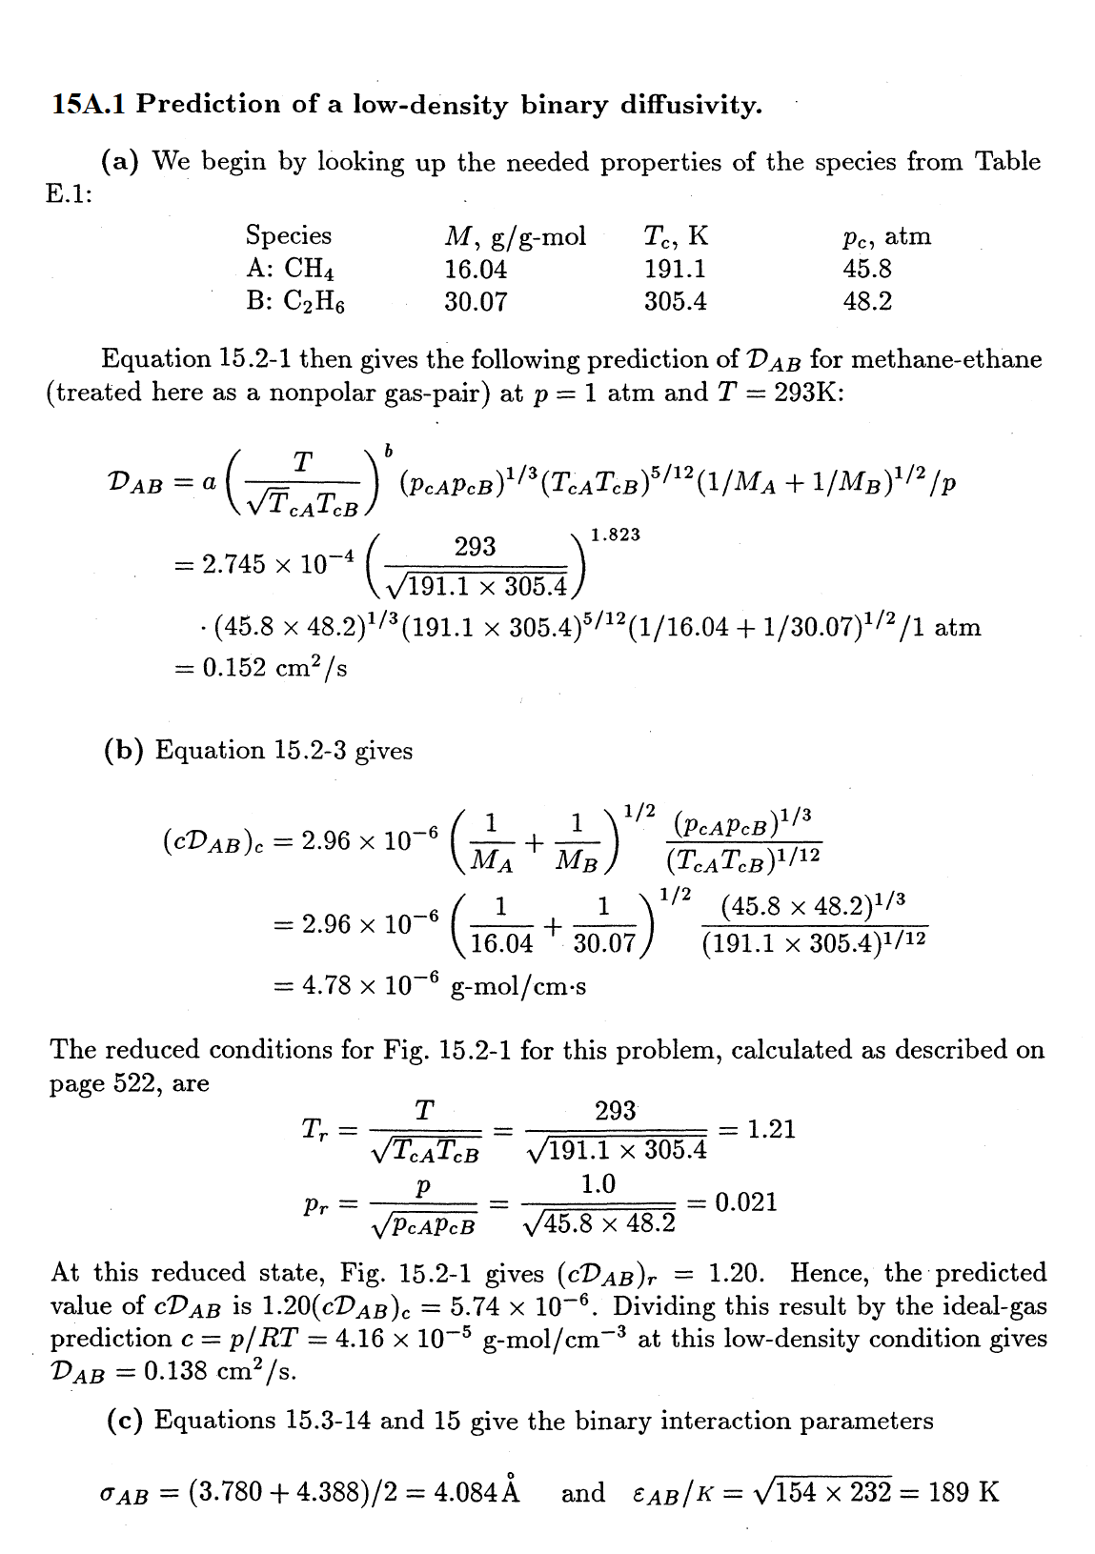

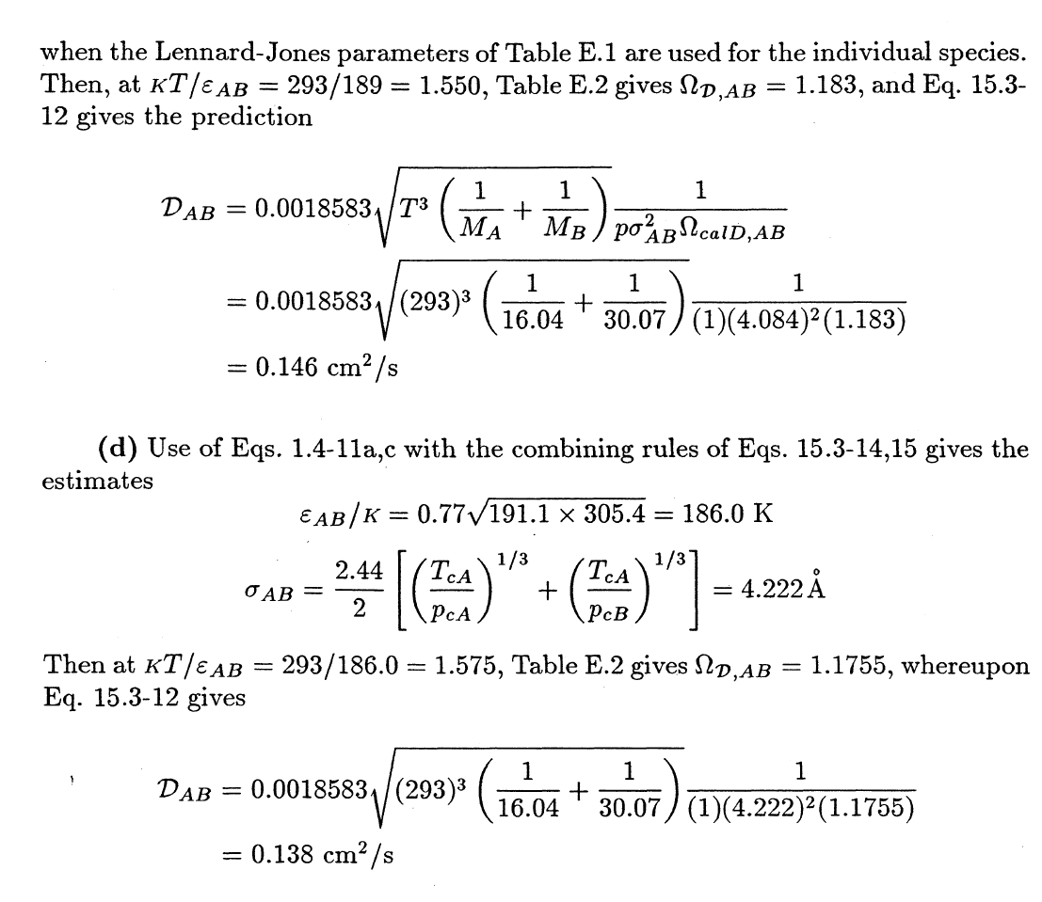

**(e)** Using equation 15.2-1

$D_{AB} ∝ T^{b}$, *b* is 1.823 for nonpolar gas pairs

$${(D}_{AB})_{600K} = {(D}_{AB})_{293 K}×(600/293)^{1.823}$$

$${(D}_{AB})_{600K} = 0.152 cm^{2}/s×(600/293)^{1.823}=0.561 cm^{2}/s$$

Using equation 15.3-10 with $n=p/kT$, predicts $D_{AB} ∝ T^{3/2}$

$${(D}_{AB})_{600K} = {(D}_{AB})_{293 K}×(600/293)^{1.5}$$

$${(D}_{AB})_{600K} = 0.152 cm^{2}/s×(600/293)^{1.5}=0.445 cm^{2}/s$$

Using equation 15.3-12 and Table E.2, with



$${(D}_{AB})_{600K} = {(D}_{AB})_{293 K}×(600/293)^{1.5}(\frac{{(Ω}_{D,AB})_{293K/ϵ_{AB}}}{{(Ω}_{D,AB})_{600K/ϵ_{AB}}})$$

$${(D}_{AB})_{600K} = 0.146 cm^{2}/s×(600/293)^{1.5}(\frac{{(Ω}_{D,AB})_{293K/ϵ_{AB}}}{{(Ω}_{D,AB})_{600K/ϵ_{AB}}})$$

And 

At 293 K, $kT/ϵ_{AB}=1.550$ and from Table E.2 gives ${(Ω}_{D,AB})_{293K/ϵ_{AB}}=1.183$

At 600 K, $kT/ϵ_{AB}=600/189=3.175$ and from Table E.2 gives ${(Ω}_{D,AB})_{600K/ϵ_{AB}}=0.93595$

$${(D}_{AB})_{600K} = 0.146 cm^{2}/s×(600/293)^{1.5}(\frac{1.183}{0.93595})=0.5387 cm^{2}/s$$

**15A.2 Self-diffusion in liquid mercury.**

Equation 15.4-5 gives

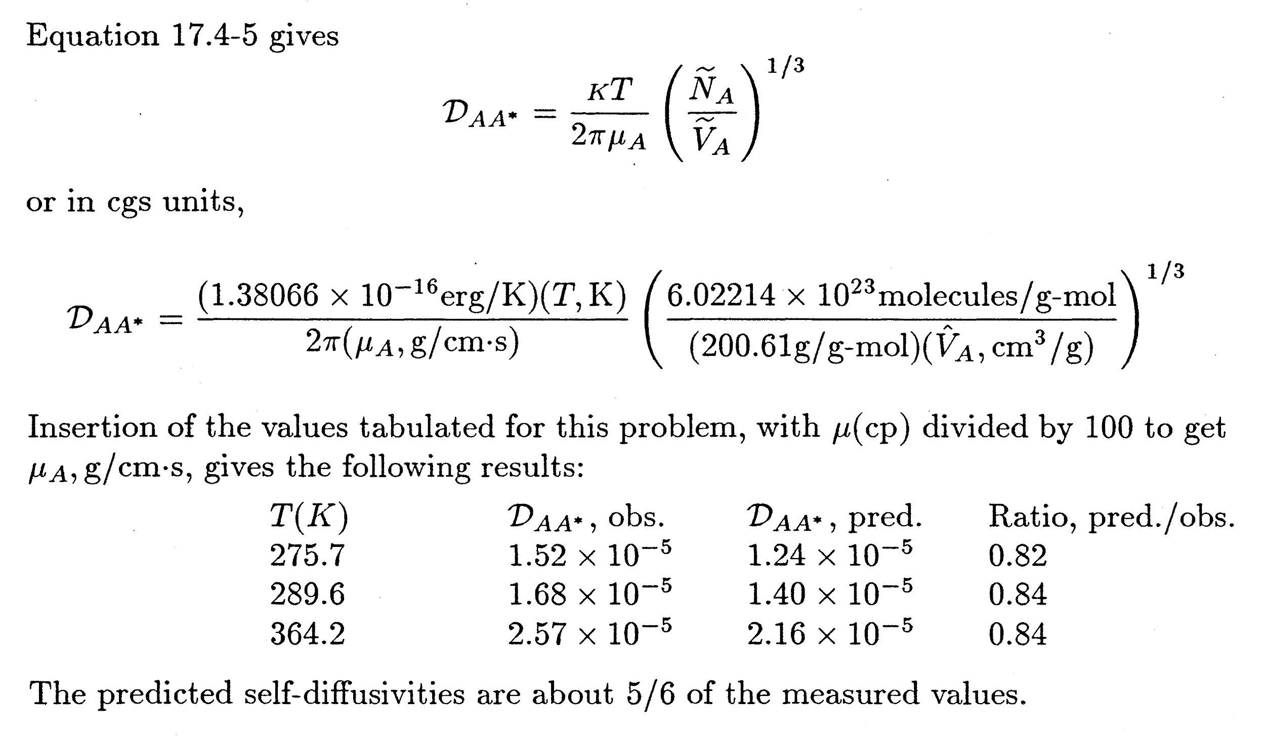

At 473 K, the Eq. 15.4-5 predicts, 3.50 × 10-5

The linear extrapolated value is 3.87 × 10-5

**15A.3 Estimation of diffusivity for a binary mixture at high density.**

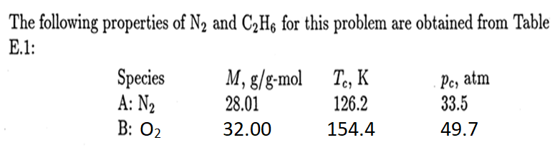

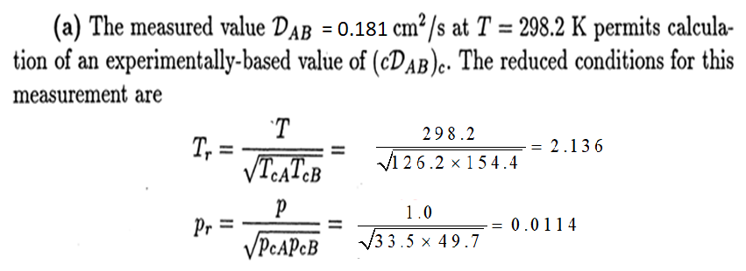

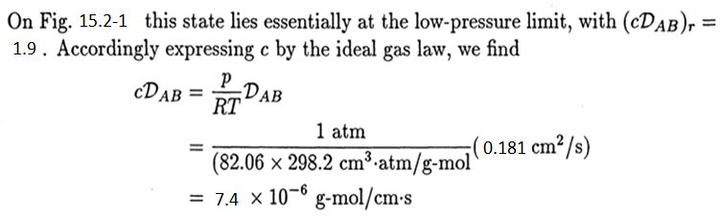

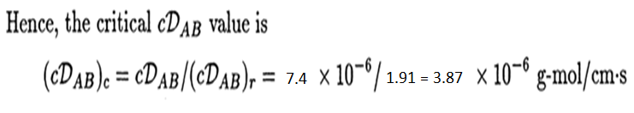

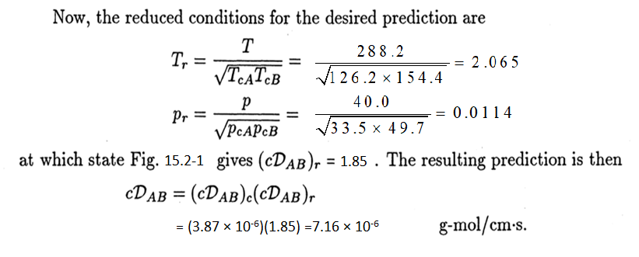

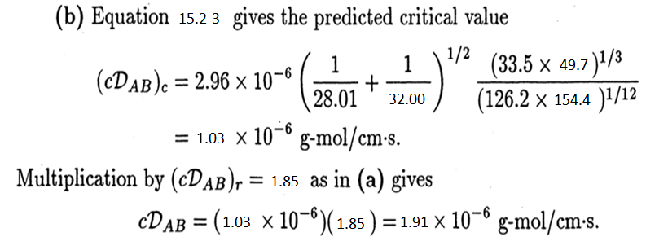

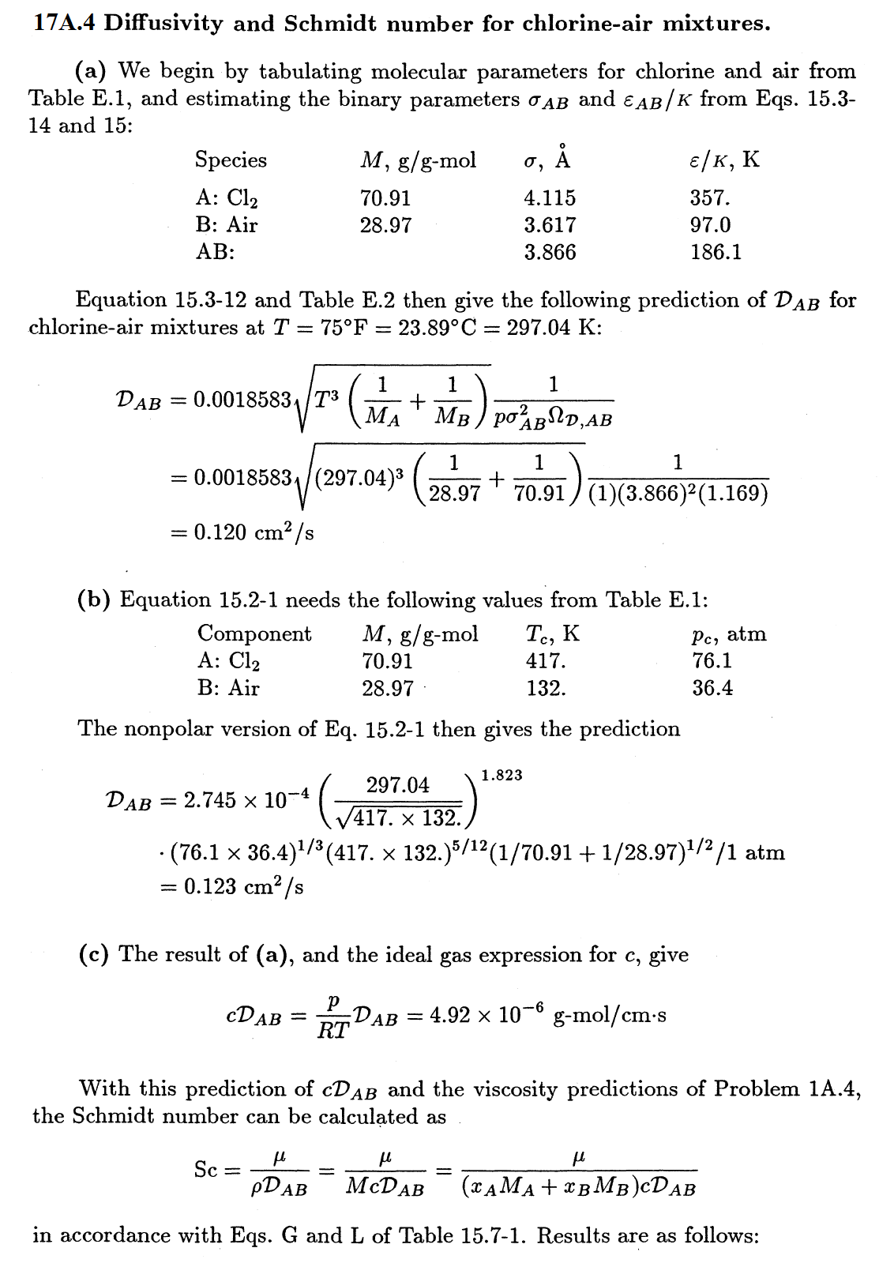

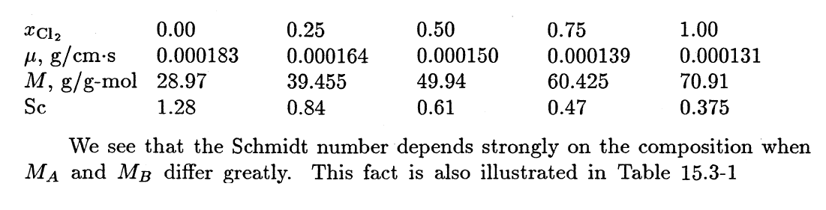

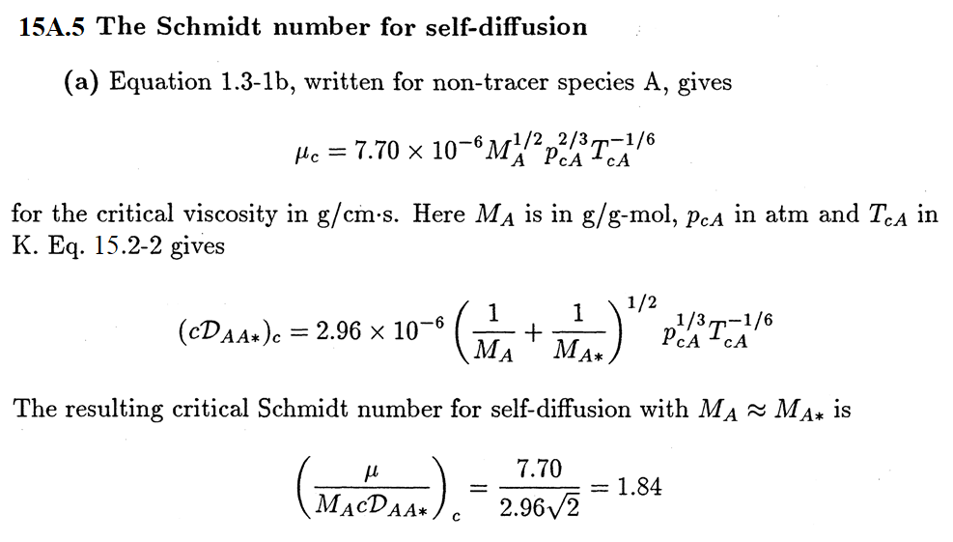

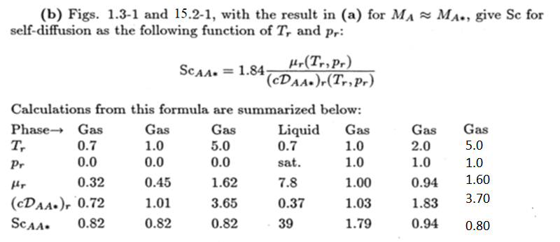

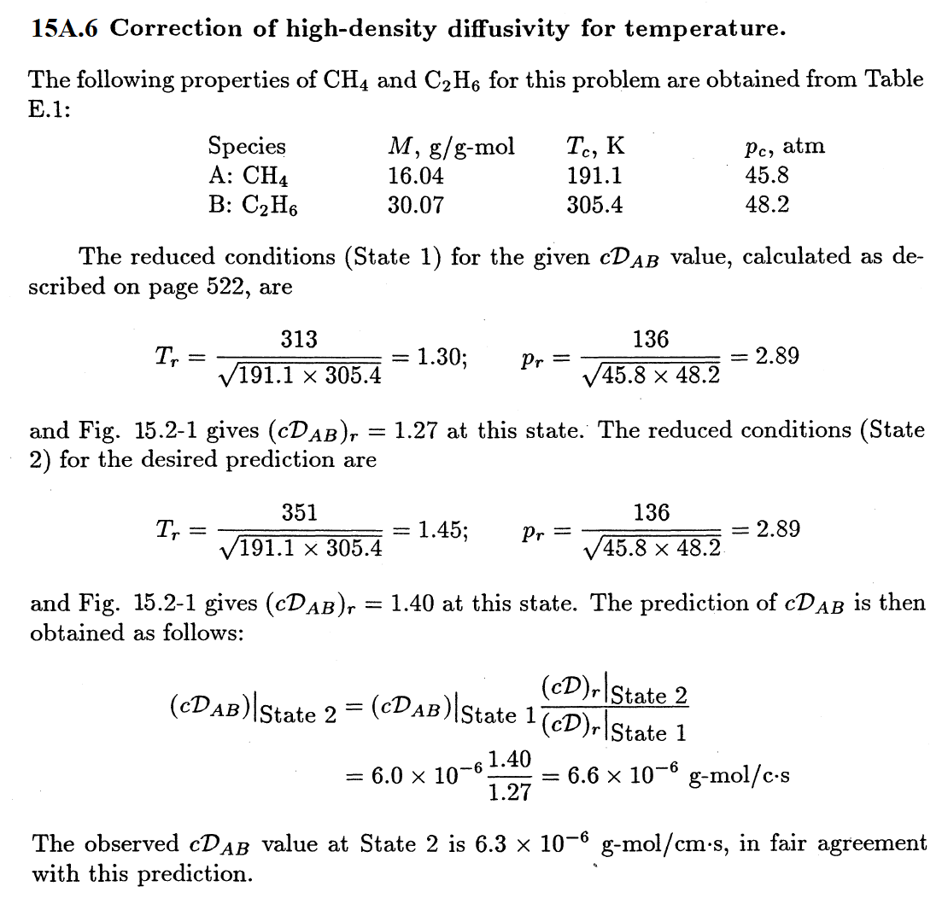

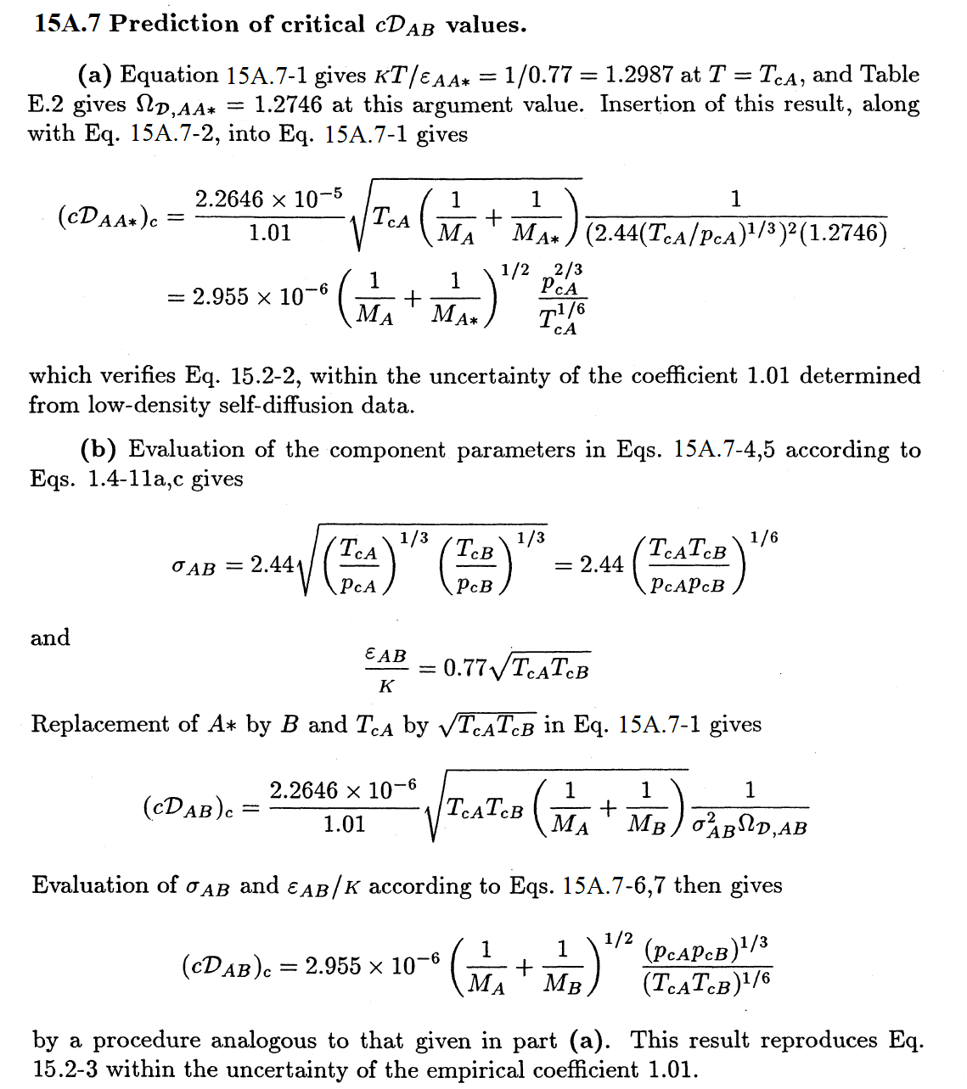

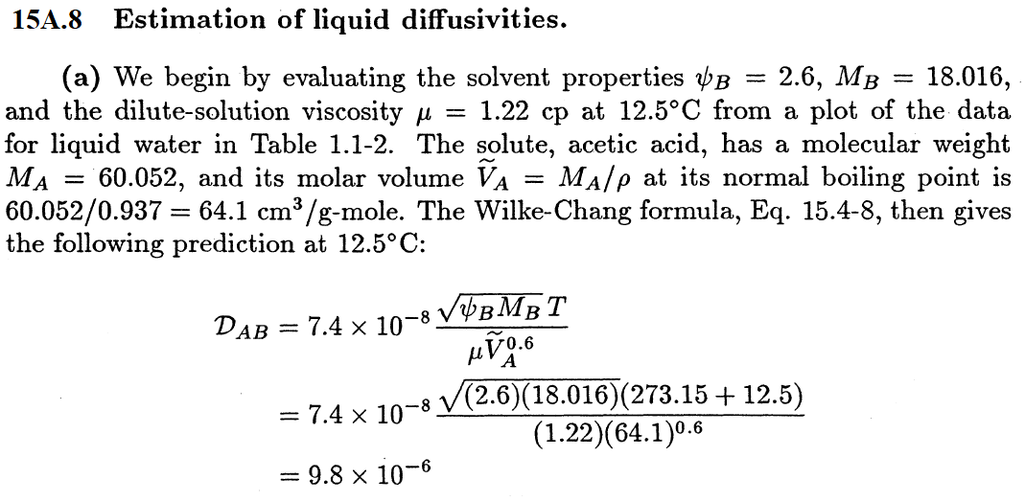

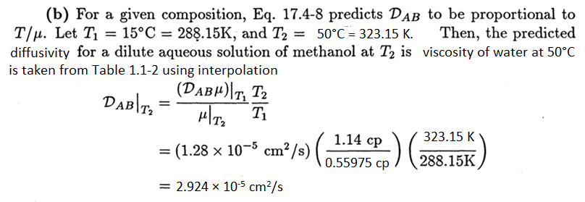

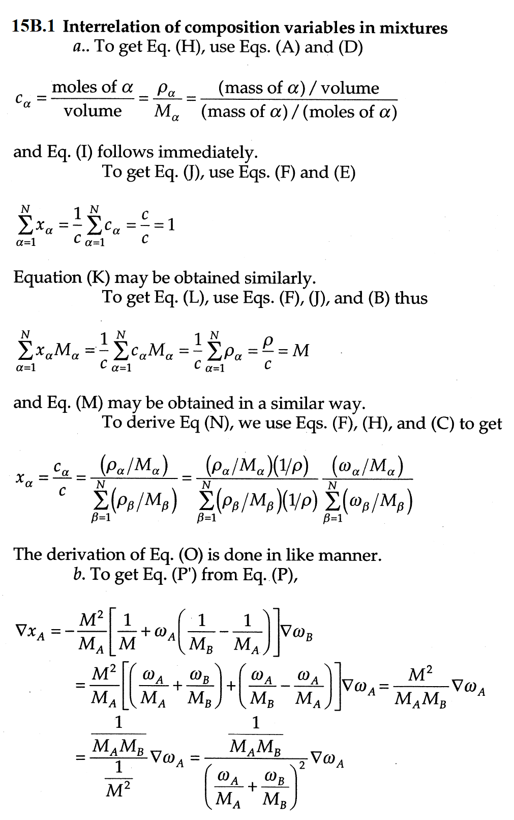

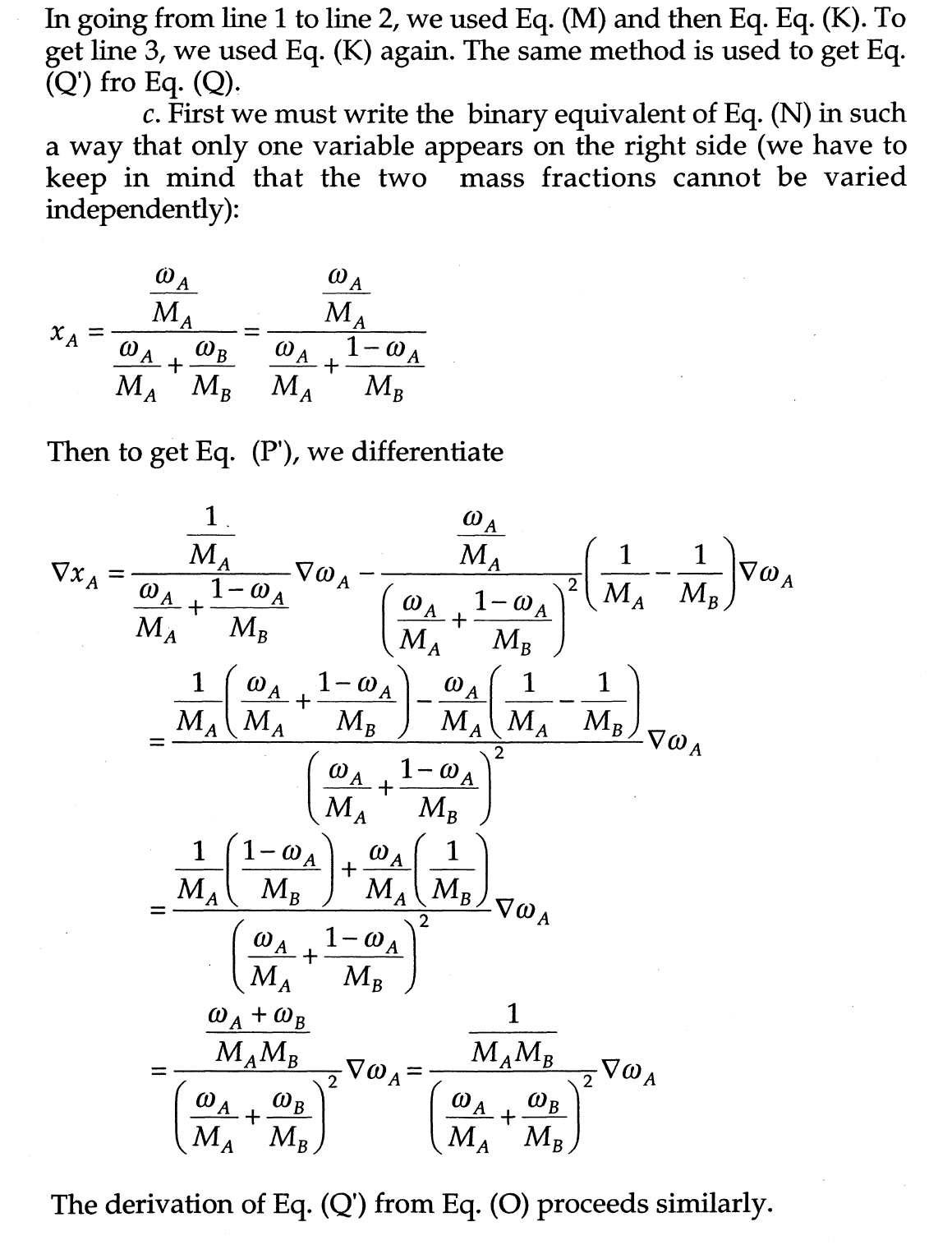

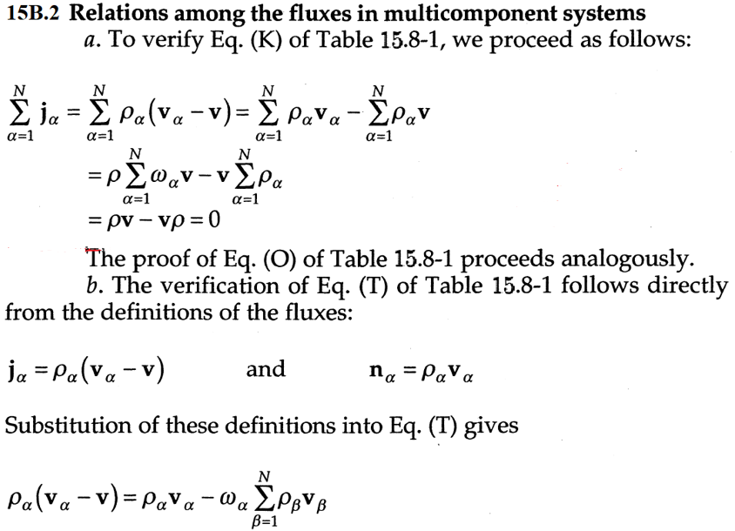

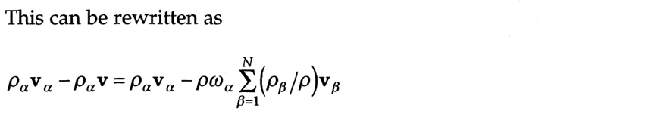

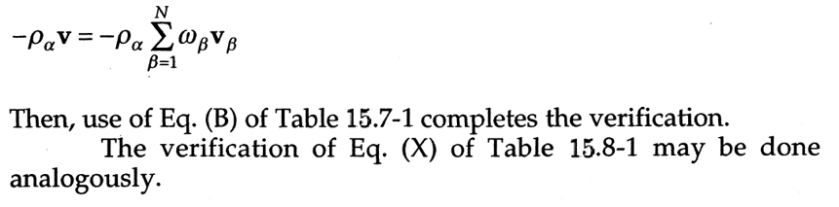

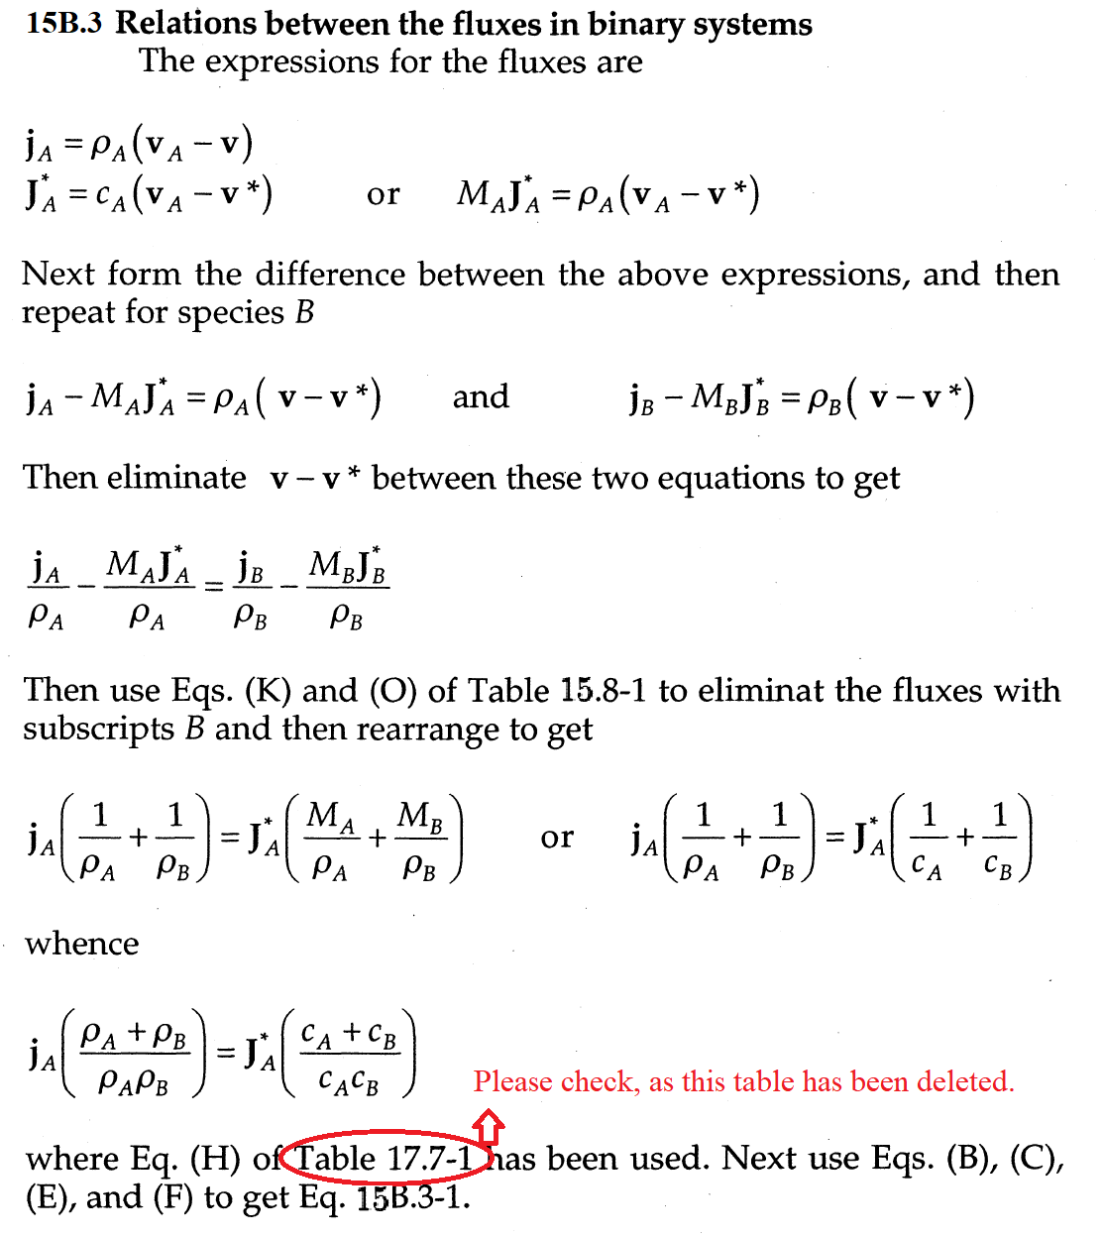

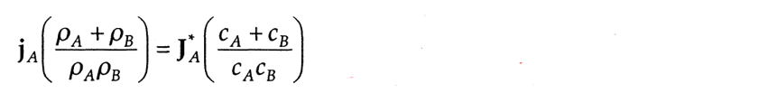

Eqs. (B), (C), (E), and (F) used to get 15B.3-1.

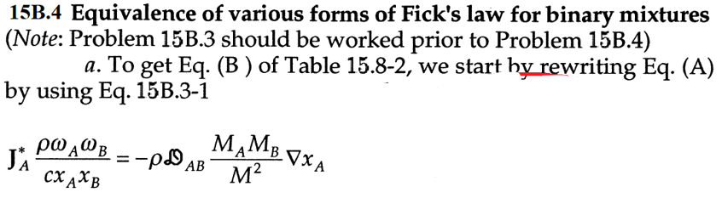

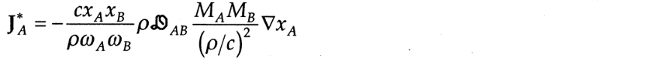

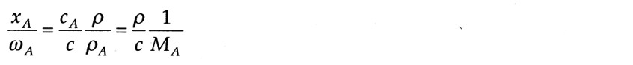

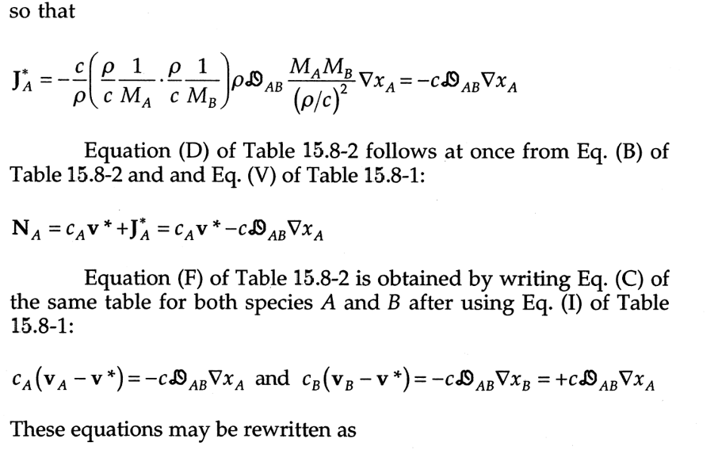

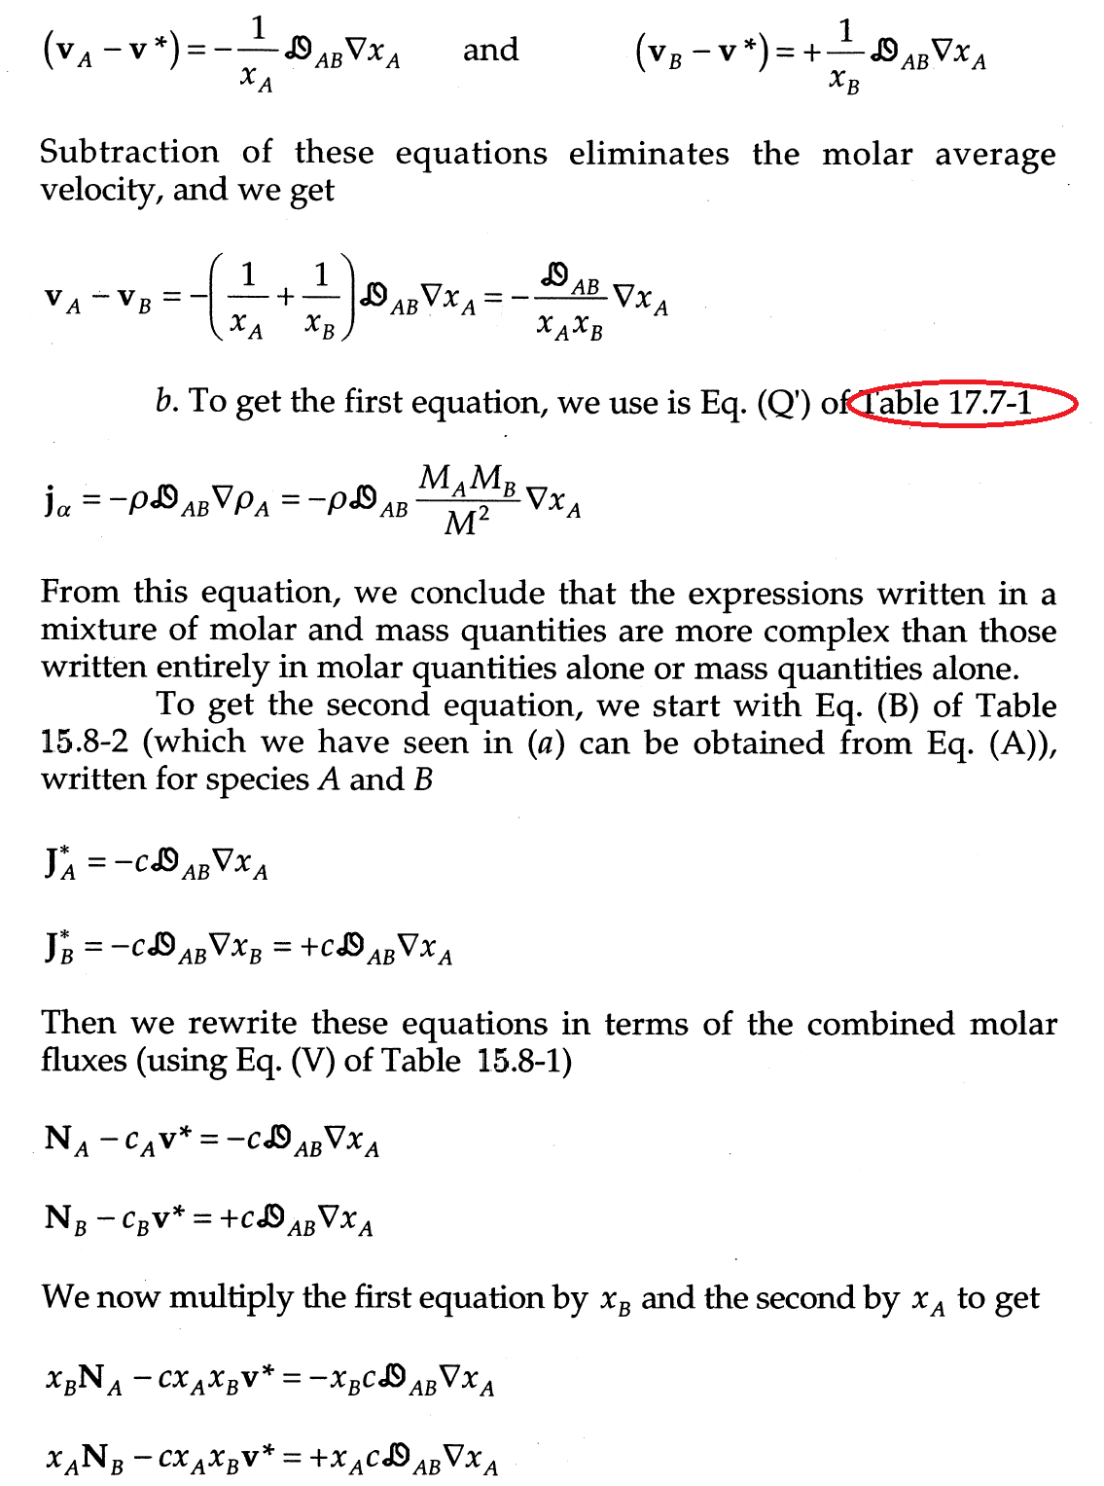

**b.** We get,



