**Solution Manual for Chapter – 14**

**14A.1. Approximation of a black body by a hole in a sphere.**

From Table 14.2.1, for oxidized copper, *e* = 0.57.

Use Eq. 14.2-12

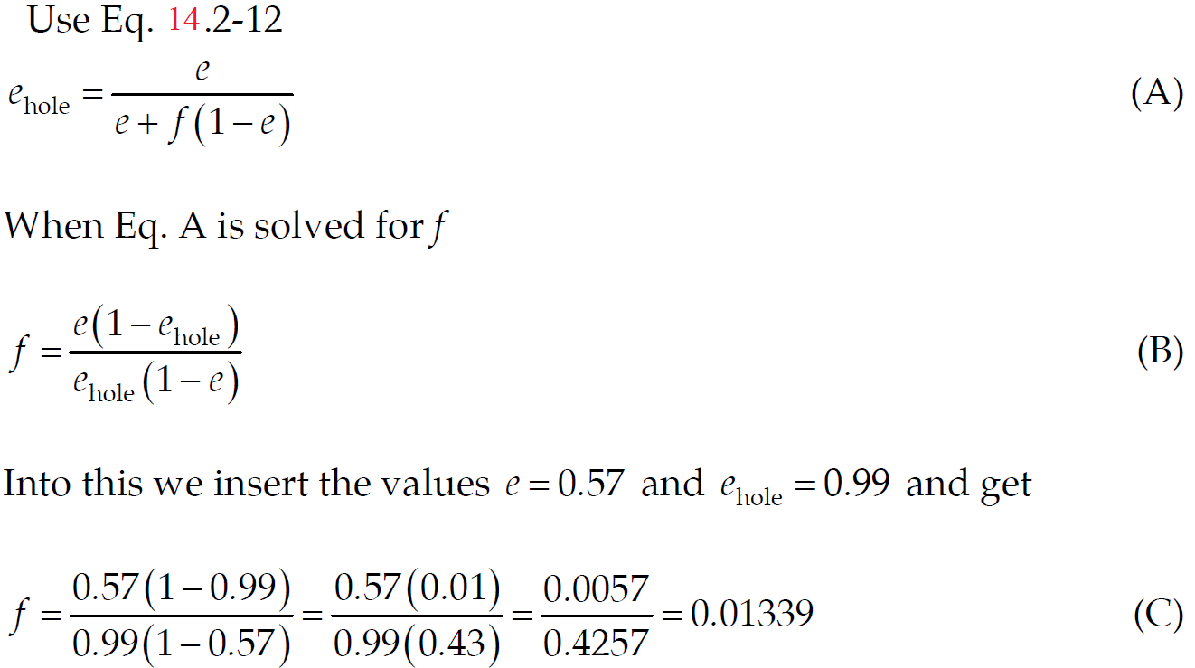

Then using the definition of *f*, we write

 (D)

Then solving for the hole radius, we get

 (E)

**14A.2 Efﬁciency of a solar engine.**

The area of the mirror is $πR^{2}=π×(1.{5 m)}^{2} = 7.07 m^{2}$.

Since the solar constant (heat flux entering the earth's atmosphere) is, according to Example 14.4-1, 1.35 kW/m2, the energy input to the solar device is

$$(1.35 kW/m^{2})(7.07 m^{2})=9.5445 kW$$

Therefore, the efficiency of the solar device is

Efficiency $=\frac{1.49}{9.5445}=0.156 or 15.6\%$

**14A.3 Radiant heating requirement.**

As the floor is totally covered by roof and walls, taking the view factor as 1 and as all surfaces are black so emissivity is also 1.

In this case, the heat transfer can be represented by

*A*1 = 50 m2 = 500000 cm2

**14A.4 Steady-state temperature of a roof.**

Since June 21 is (conveniently) very close to the summer solstice, the angle of incidence of the sun's rays on a ﬂat roof may be calculated quite simply. We know that the earth's axis is tilted at an angle of about 23.5 degrees. Thus, the angle of incidence of a ﬂat roof at 4.5 degrees north latitude will be about $45-23.5=21.5$ degrees.

The heat received by the roof will be given by the solar constant multiplied by the cosine of the angle of incidence and then further multiplied by the absorptivity of the surface: $(1.35 kW/m^{2}) (cos 21.5°)a=(1.35×10^{3})(0.9304)a$ in units of W/m2.

We now equate the radiant energy received from the sun by the roof to the radiant energy emitted by the roof plus the heat lost by convective heat transfer for the two cases given in parts (a) and (b):

$$(1.35×10^{3})(0.9304)a=h(T_{roof}-T_{air})+σe T_{roof}^{4}$$

(a) For a perfectly black roof, we have

$σ=5.67×10^{-8} W/m^{2}·K$

$e=a=1$ for perfectly black

$$(1.35×10^{3})(0.9304)(1.00)=11.5(T_{roof}-310)+5.67×10^{-8 }(1.00) T_{roof}^{4}$$

This equation may be solved by trial and error to get $T_{roof}=347.4 K$

(b) For the ﬂat roof with $a=0.3$ and $e=0.07$ we get,

$σ=5.67×10^{-8} W/m^{2}·K$

$$(1.35×10^{3})(0.9304)(0.3)=11.5(T_{roof}-310)+5.67×10^{-8 }(0.07) T_{roof}^{4}$$

This equation may be solved by trial and error to get $T_{roof}=338.2 K$

**14A.5 Radiation errors in temperature measurements.**

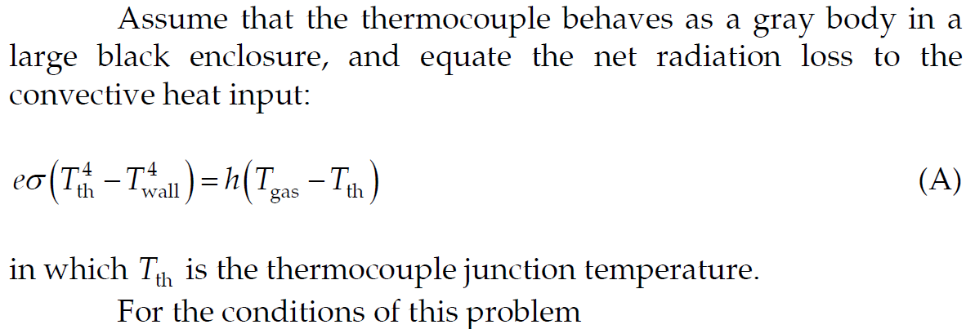

*e* = 0.8

𝜎 = 5.670 x 10-8 W/m2 K4

*h* = 280 W/m2 °C

*T*th = 260 °C = 533 K

*T*wall = 150 °C = 423 K

Substituting above values in the equation (A)

$$\left(0.8\right)\left(5.670 × 10^{-8}\right)\left(533^{4}-423^{4}\right)=280\left(T_{gas}-533\right)$$

Solving this for *T*gas we get

*T*gas = 540.9 K

There is thus a 7.9 K difference between the calculated gas temperature and the thermocouple reading.

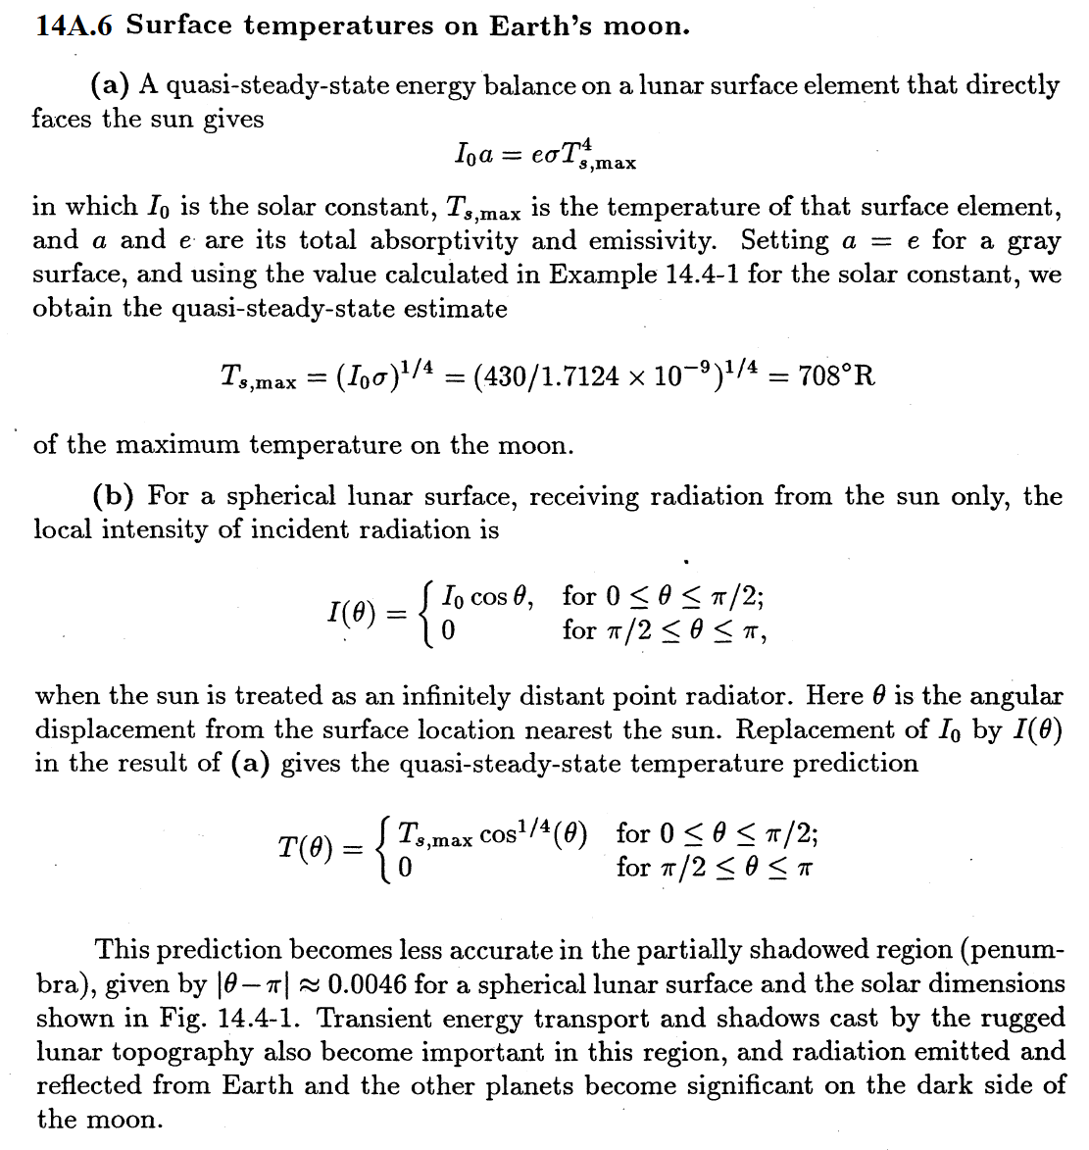

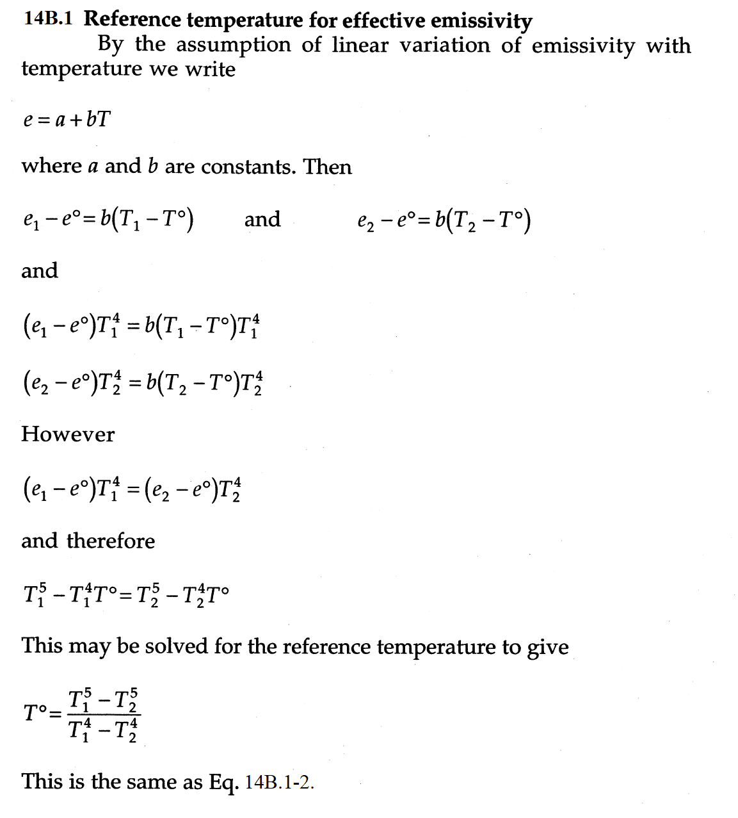

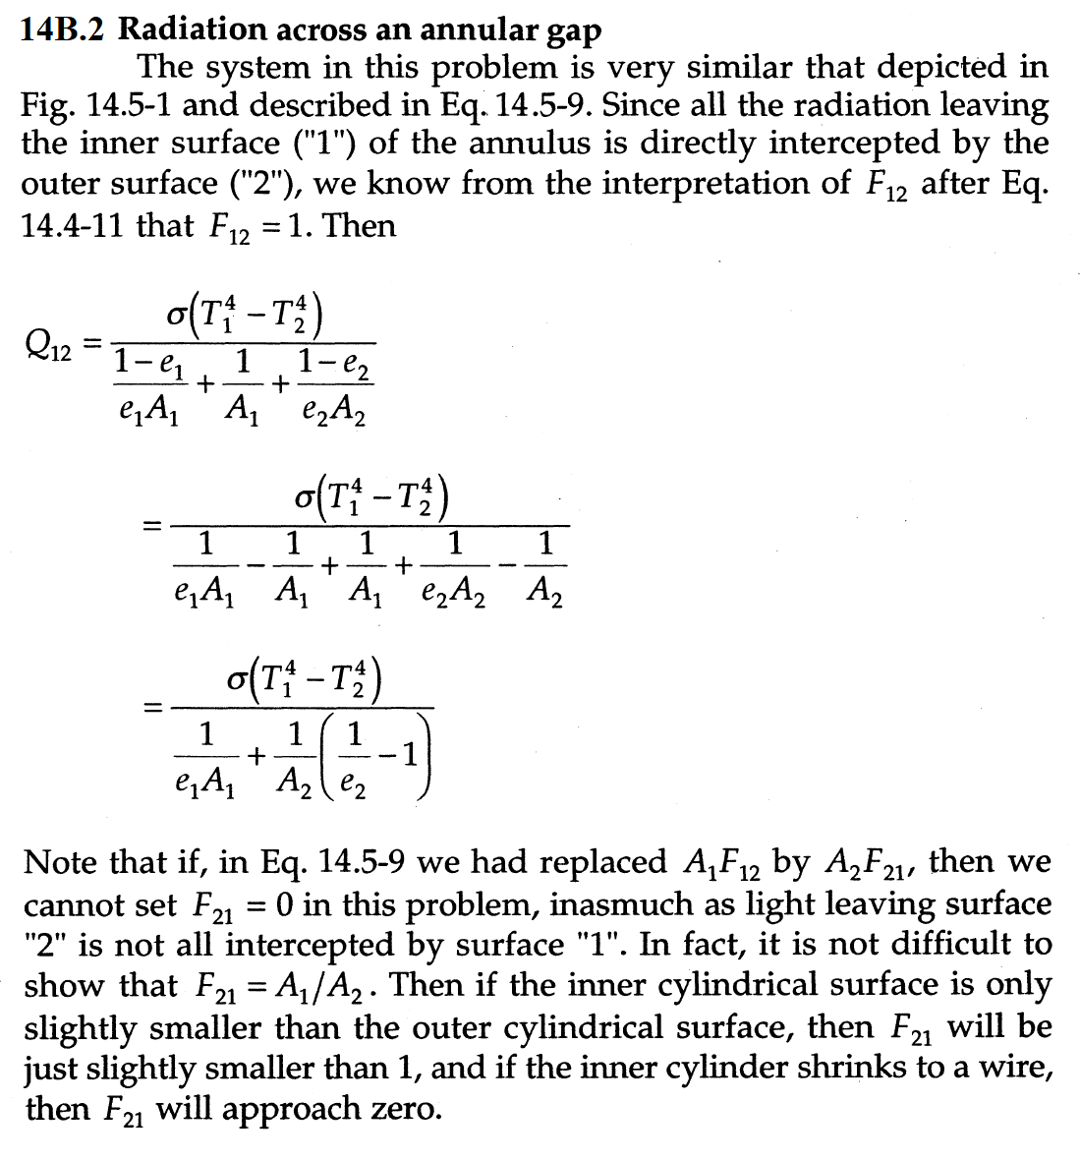

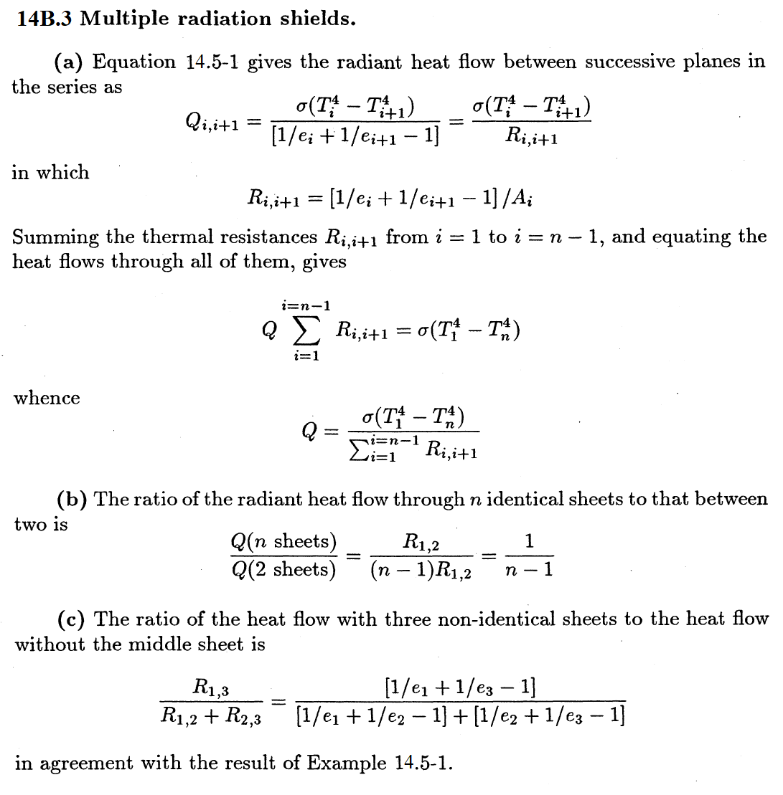

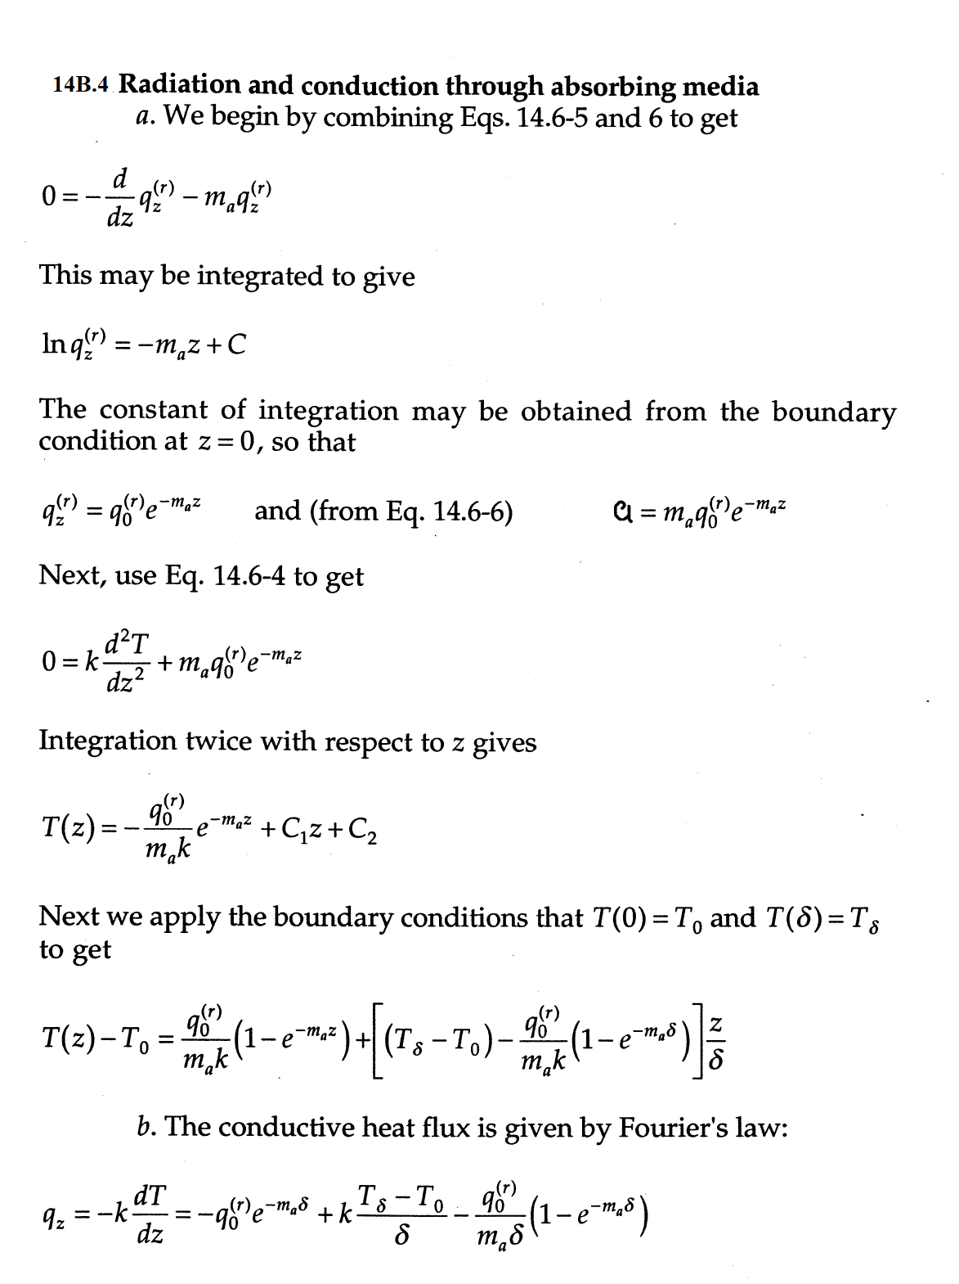

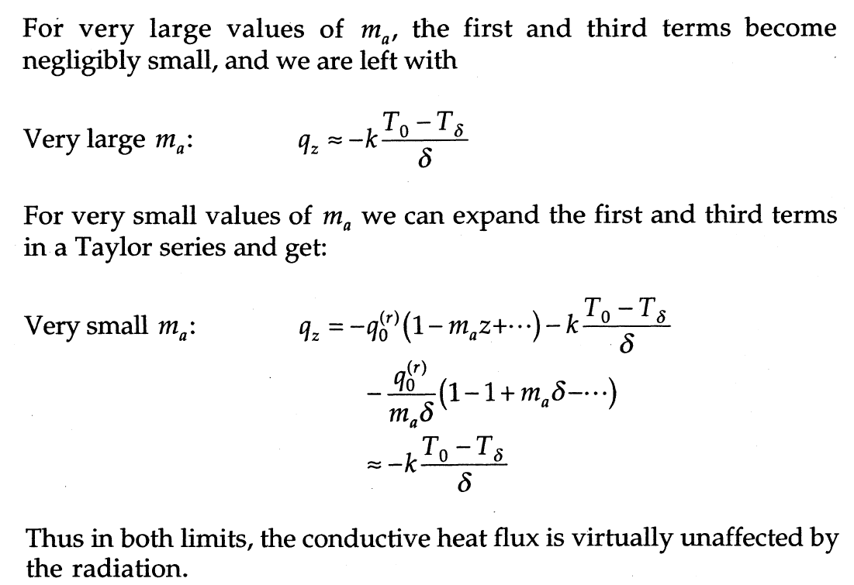

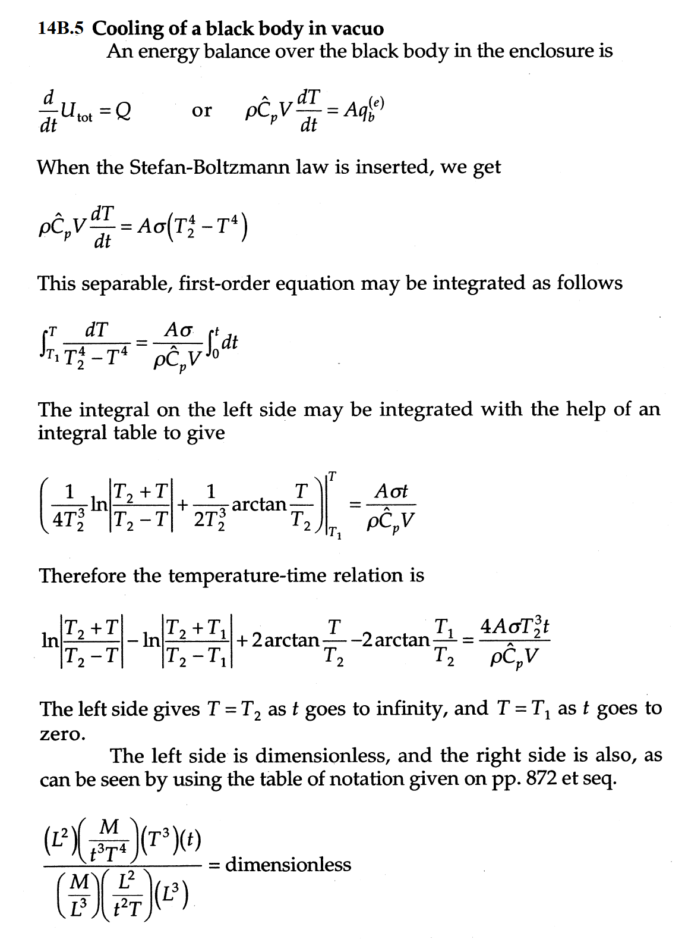

**14B.6. Heat loss from an insulated pipe.**

(a)Eq. 9.2-29 gives for this problem

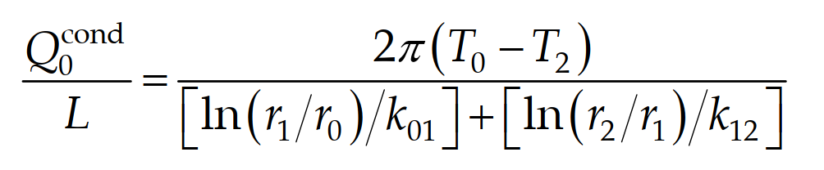

In which

$r_{0}=2.625 cm$; $r_{1}=2.625+0.4=3.025 cm; r_{2}=3.025+5=8.025 cm$

With these dimensions and the given thermal conductivity values, we then obtain from Eq. A

$$\frac{Q^{(cond)}}{L}=\frac{2π(T_{0}-T_{2})}{\left[ln(3.025/2.625)/45\right]+\left[ln(8.025/3.025)/0.61\right]}$$

$$=\frac{2π(395-T_{2})}{3.152×10^{-3}+1.6}$$

$=333.14 W/m$ at $T_{2}=310 K$

$=0$ at $T_{2}=395 K$

(b) The net radiative heat loss is given by Eq. 14.5-3. Setting $e=a=0.05$ for the aluminum foil, we get



$$=\left(5.67×10^{-8}W/m^{2}·K^{4}\right)π\left(2×8.05×10^{-2} m\right)\left(0.05\right)\left(T_{0}^{4}-300^{4}\right)K^{4}$$

$=1.628 W/m$ at $T_{0}=310 K$

$=23.29 W/m$ at $T_{0}=395 K$

The free convection heat loss is predictable as in §14.6. For *T*a = 37 °C , Example 14.6-1 gives

$$Q^{(conv)}/L=13.79 W/m$$

For $T_{a}=395 K$, Eqs. 13.6-4,5 and the procedure outlined in §13.6 gives



The needed properties of air at (395+300)/2=347.5 K=74.35°C are obtained from the ideal gas law, from Table 1.1 2, and from CRO Handbook of Chemistry and Physics, 8181; Ed. ,2001-2002, pp. 6-1, 6-2, and 6-185.

$μ=0.0206 mPa·s$; $ρ=pM/RT=1.017 kg/m^{3}$; ${\hat{C}}_{p}=1.012×10^{-3} J/kg/K$

$k=29.5 mW/m·K$; $β=1/T_{f}=1/347.5 K$

Hence:

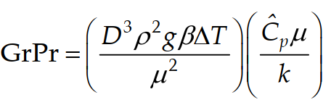

$$GrPr = \left(\frac{{{\left(8.025×2×10^{-2}\right)}^{3}\left(1.017\right)}^{2}(9.8)(1/347.5)(95)}{{\left(0.0206 × 10^{-3}\right)}^{2}}\right)\left(\frac{\left(1012\right)\left(0.0206 × 10^{-3}\right)}{0.0295}\right)$$

$$=(2.7×10^{7})×(0.707)=1.91×10^{7}$$

And

$$Nu_{m}=(0.398)(1.91×10^{7})^{1/4}=26.3$$

Therefore,

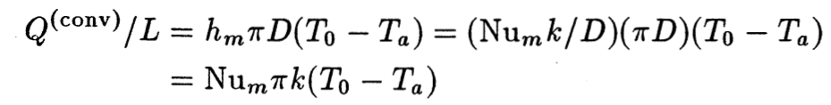

$$=(26.3)π(0.0295 W/m.K)(395-300)=231.55 W/m$$

Giving

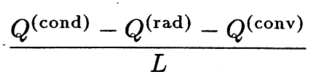

$=333.14 -1.628-13.79=318.74 W/m$ at $T_{0}=310 K$

$=0-23.29-231.55= -254.84 W/m$ at ${ T}_{0}=395 K$

(c) Linear interpolation to zero heat accumulation at the outer surface gives the steady-state values

$$T_{0}=300+\frac{318.74}{(318.74+254.84)}(395-300)=352.79 K$$

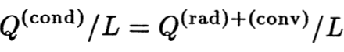

$$=333.14+[(318.74)/(318+254.84)](0-333.14)=148$$