**Solution Manual for Chapter – 12**

**12A.1 Wall heat flux for turbulent flow in tubes (approximate)**

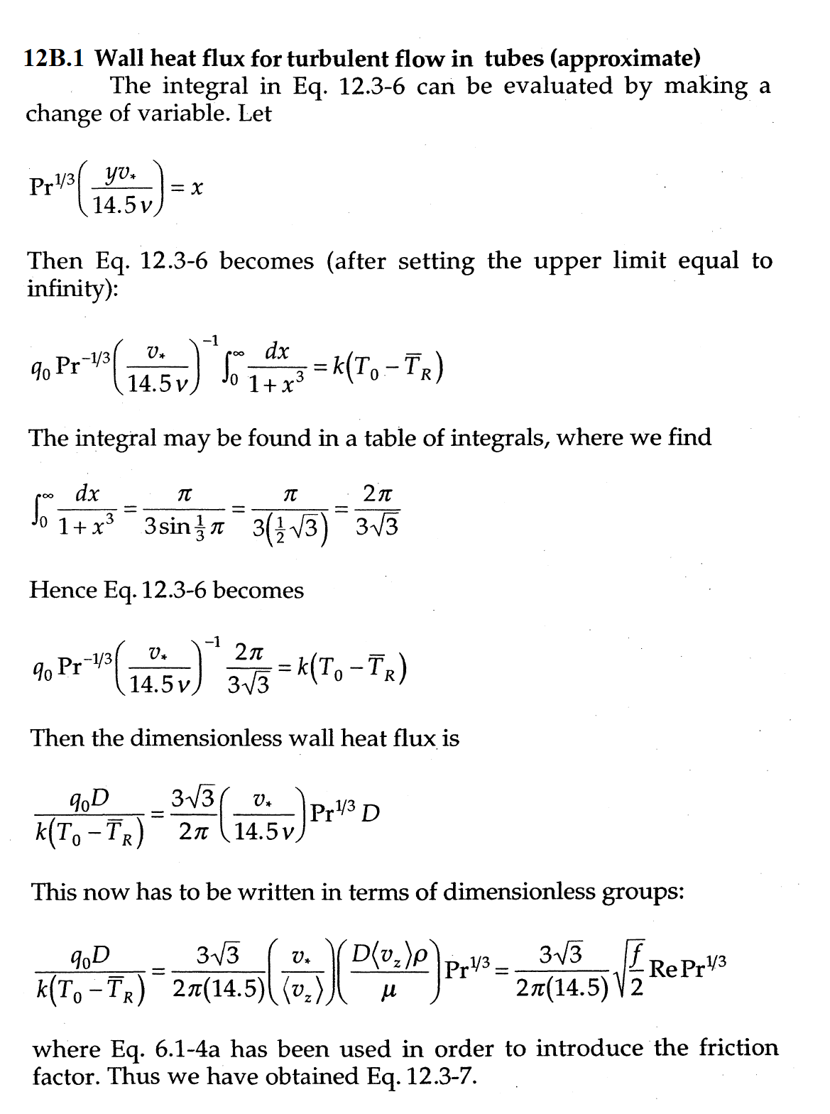

**12A.2 Wall of heat flux for turbulent flow in tubes**

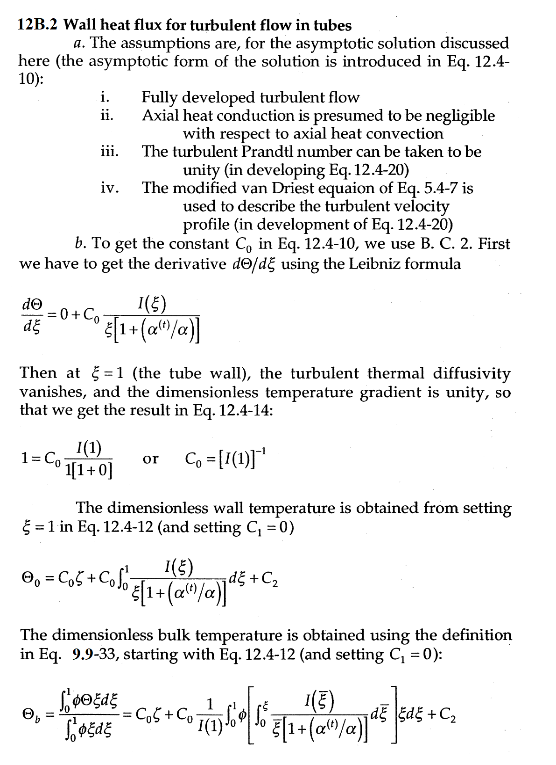

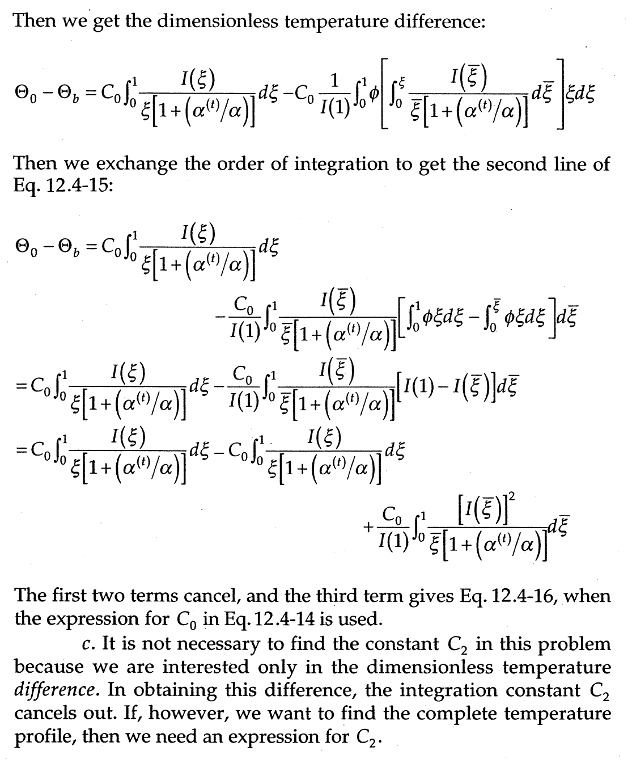

***d*. Substituting the values of *f* and *α*(+) into Eq. 12.4-16**



** (12.4-16)**











**Now,**













**We know**

** (See the entry in Table 14.2-1)**

**For plug flow**





** (1)**



**Now, substituting the values back in Eq. (1), we have**





**Again,**

** (See the entry in Table 14.2-1)**

**12B.1 Constant wall heat flux for turbulent flow between two parallel walls**

