**Manual for Chapter – 11**

**11A.1 Unsteady-state heat conduction in an iron sphere.**

1. The thermal diffusivity of the sphere is given by Eq. 8.1-8:
$$α=\frac{k}{ρ{\hat{C}}_{p}}=\frac{52 W/m.K }{6984 kg/m^{3} ×0.5×10^{3} J/kg.K}=1.49×10^{-5} m^{2}/s$$

2. The center temperature is to be 53°C; hence

$$\frac{T_{ctr}-T_{0}}{T_{1}-T_{0}}=\frac{53-21}{132-21}=0.29$$

Then, from Fig. 12.1-3, $αt/R^{2}=0.1$, and

$$t=0.1\left(\frac{R^{2}}{α}\right)=0.1\left(\frac{(1.25×10^{-2})^{2}}{1.49×10^{-5}}\right)=1.05 s$$

1. By equating the dimensionless times, we get



$\frac{α_{1}t_{1}}{{R_{1}}^{2}}=\frac{α_{2}t_{2}}{{R_{2}}^{2}}$**or $α_{2}=α_{1}\left(\frac{t_{1}}{t_{2}}\right)=1.49×10^{-5}\left(\frac{1}{2}\right)=7.45×10^{-6} m^{2}/s$**

1. The partial differential equation from which Fig. 11.3-3 was constructed is

$$\frac{∂T}{∂t}=α\frac{1}{r^{2}}\frac{∂}{∂r}\left(r^{2}\frac{∂T}{∂r}\right)$$

**11A.2 Comparison of the two slabs for short times.**

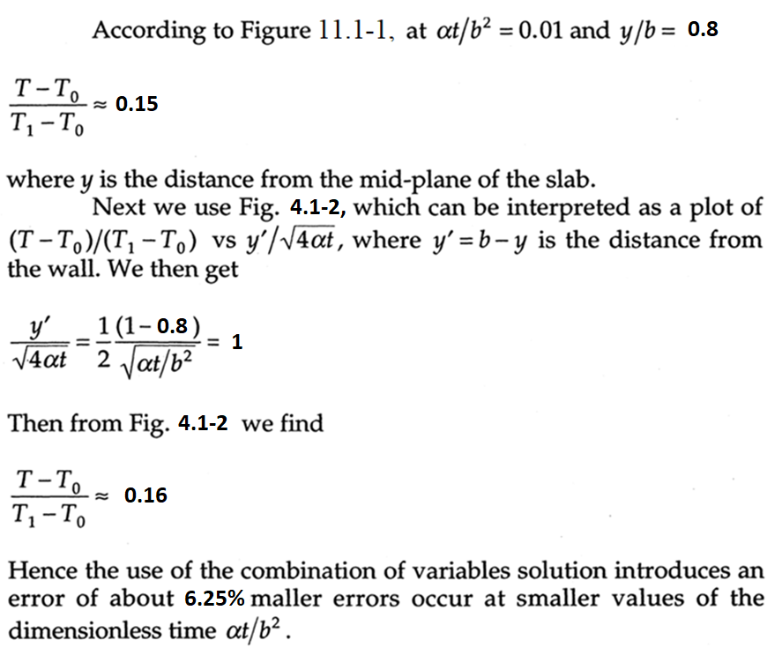

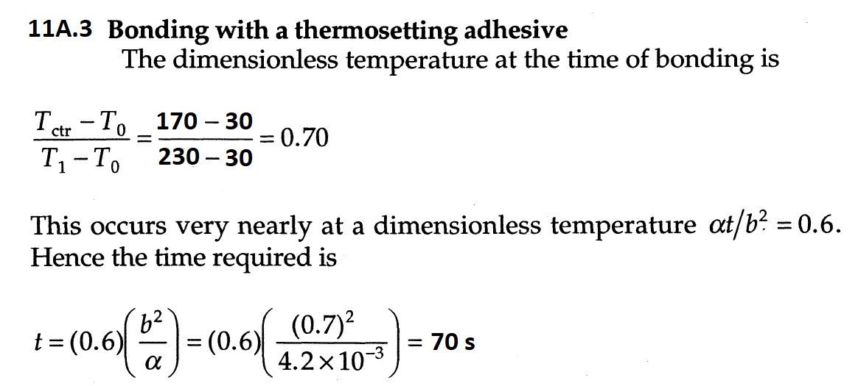

**11A.4. Quenching of a steel billet.**

The thermal diffusivity of the steel billet is

$$α=\frac{k}{ρC_{p}}=\frac{\left(43\right)}{\left(7700\right)\left(502.4\right)}=1.11 × 10^{-5}m^{2}/s$$

The dimensionless time is then

$$\frac{αt}{R^{2}}=\frac{\left(1.11 × 10^{-5}\right)\left(300\right)}{{\left(0.15\right)}^{2}}=0.148$$

From Fig. 11.1-2, the dimensionless centre-line temperature is about 0.31. Therefore

$$\frac{T_{centre}-T_{0}}{T_{1}-T_{0}}=0.31$$

*T*centre = 0.31 (*T*1 -T0 ) + T0 = 0.31 (95 - 535) + 535 ≈ 399 °C

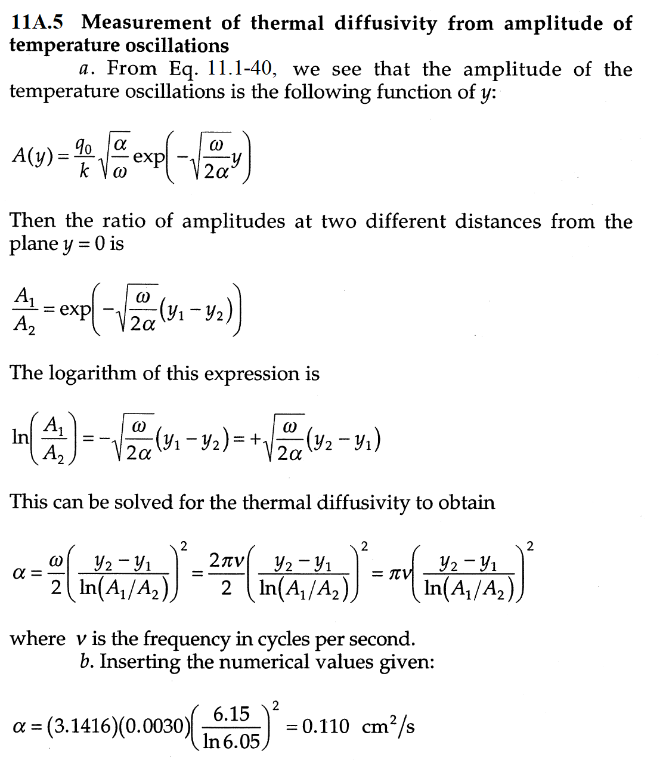

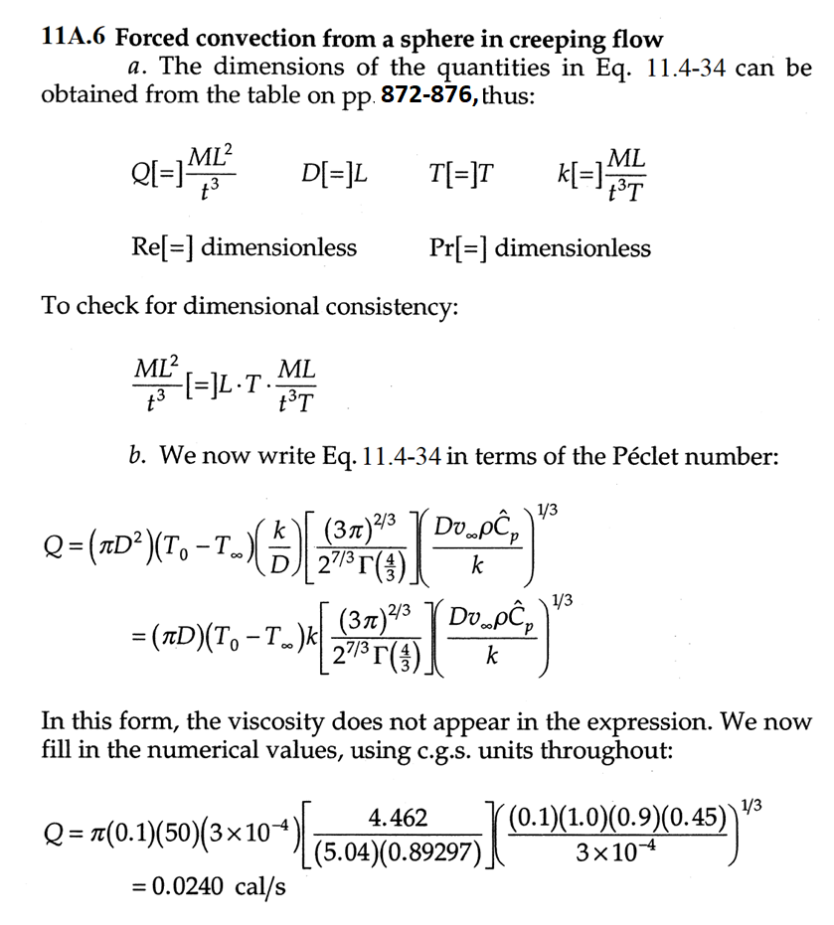

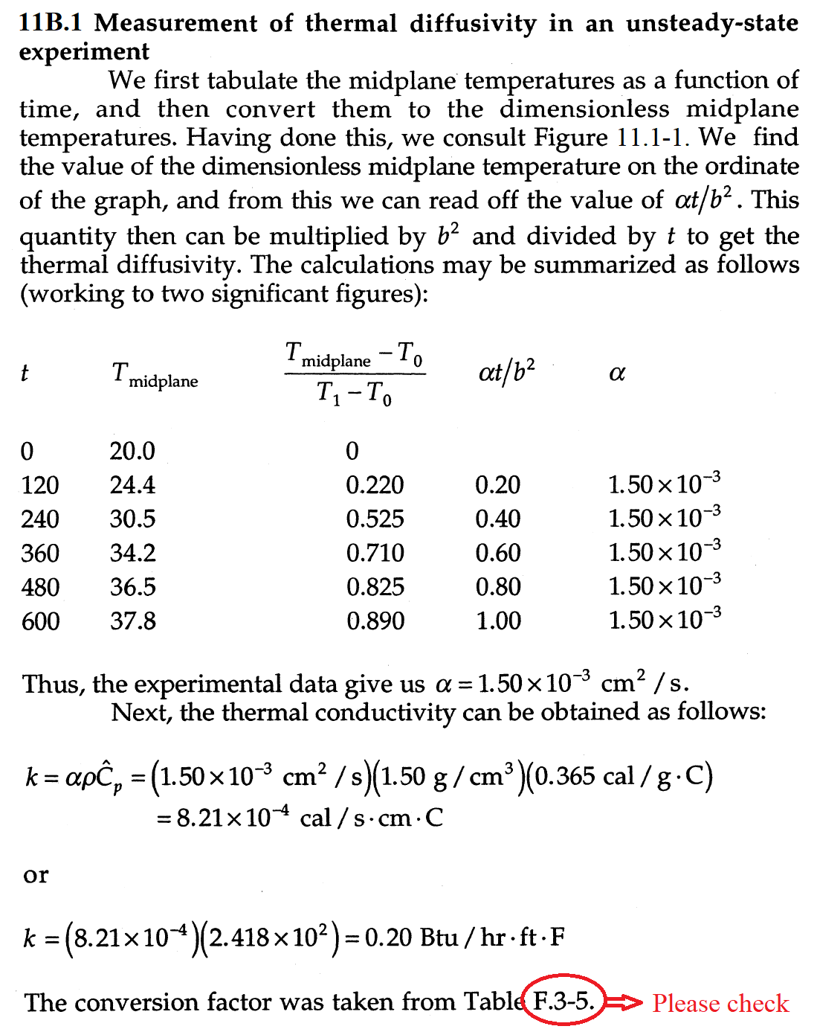

The conversion factor was taken from Table F.3-5.

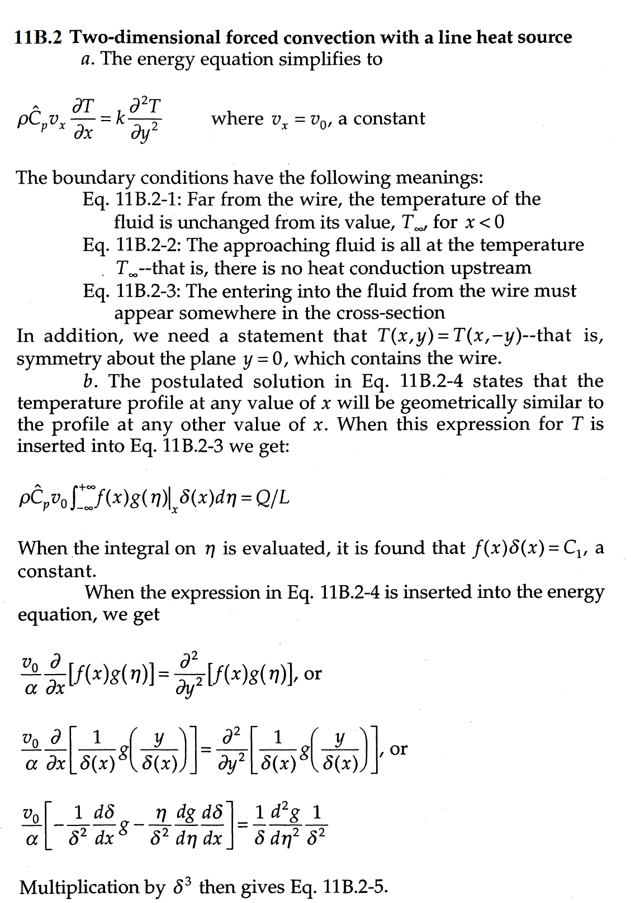

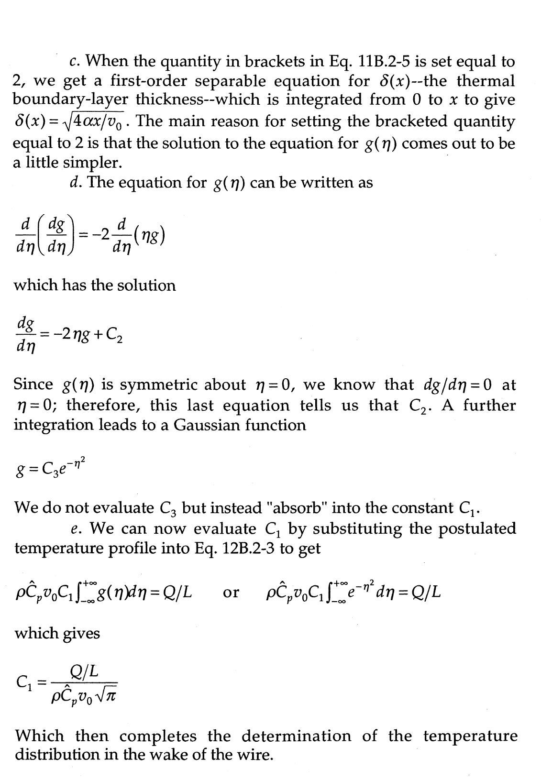

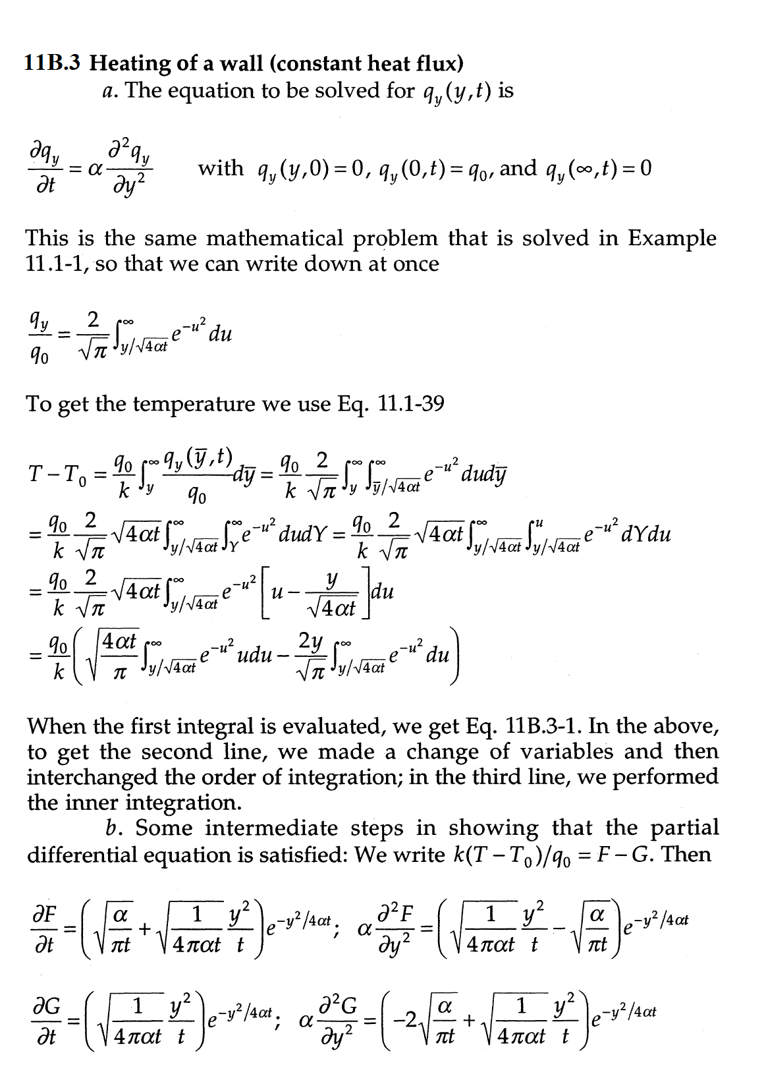

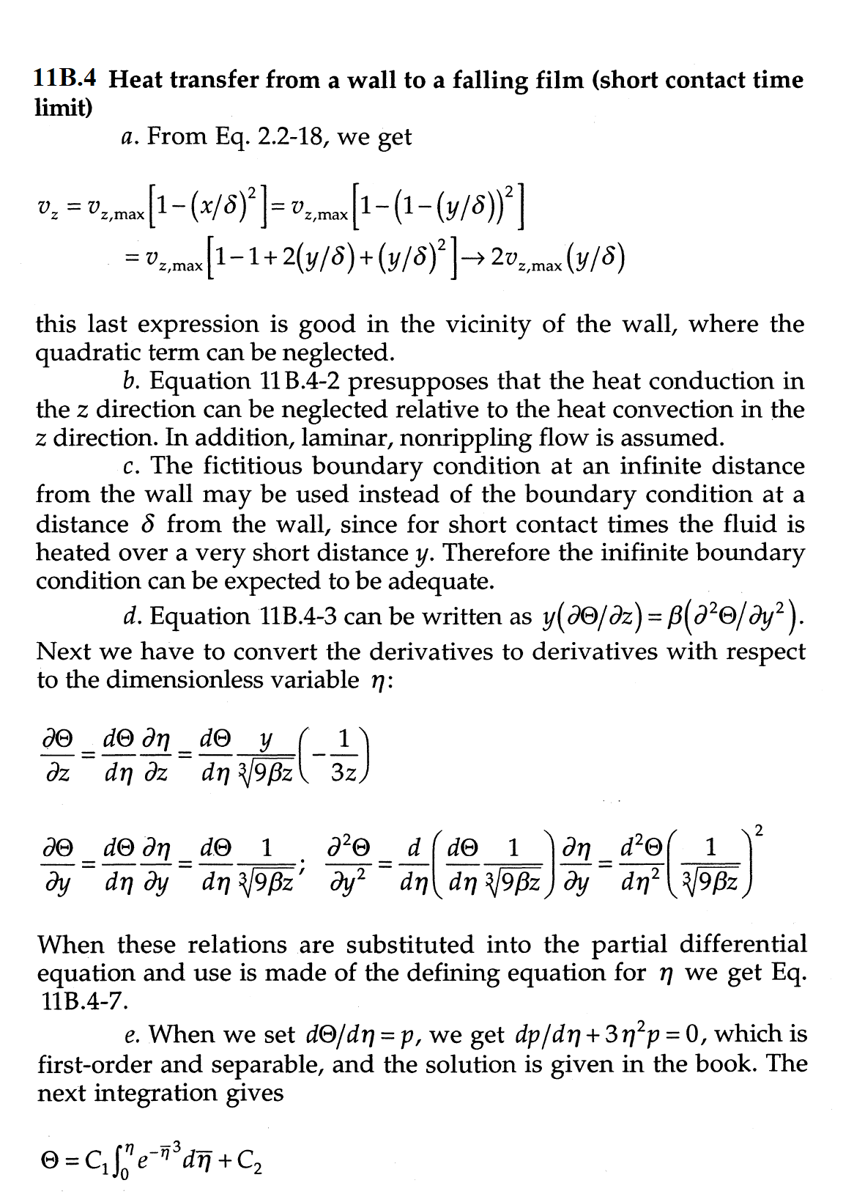

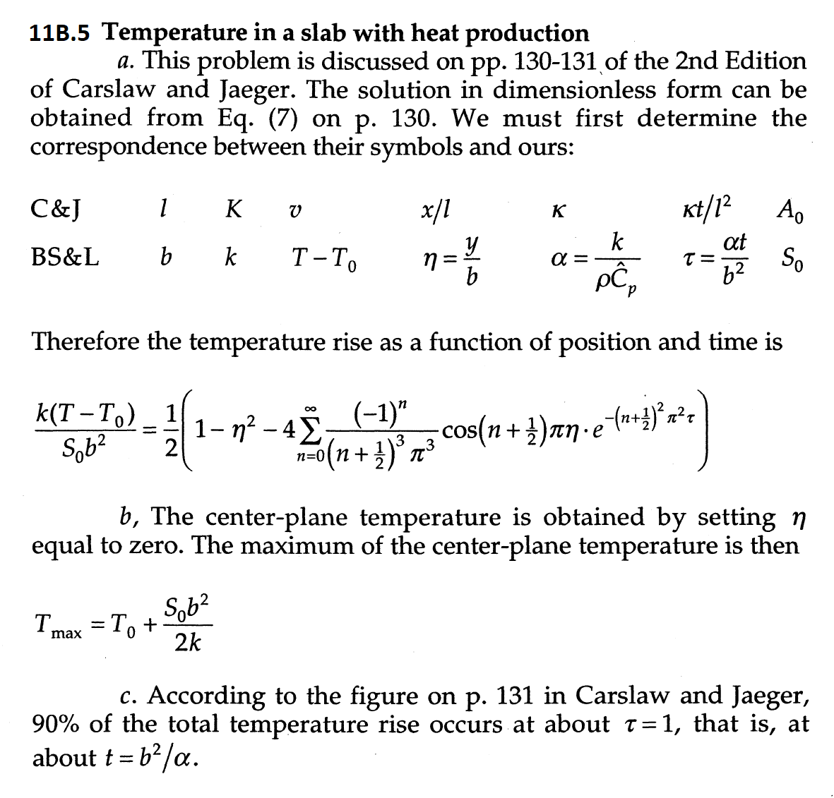

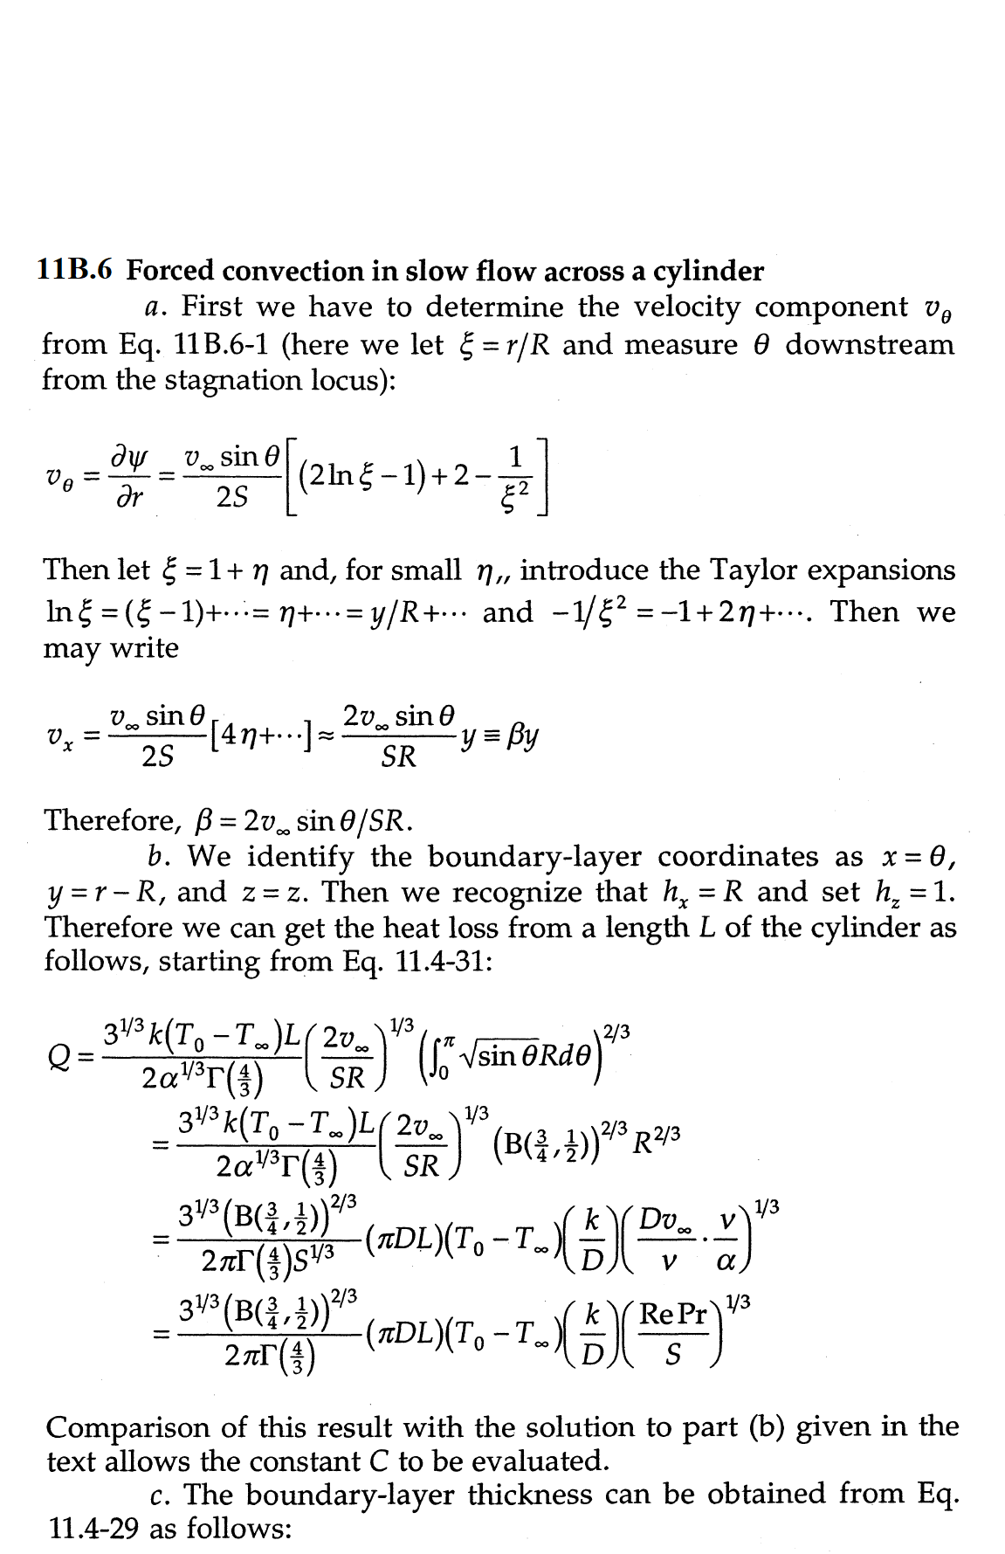

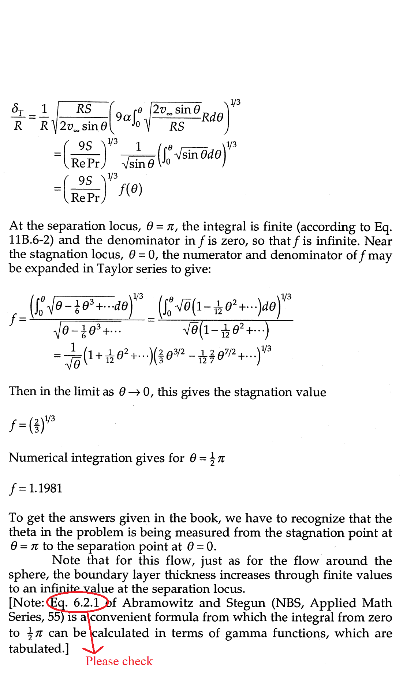



**11B.7 Timetable for roasting turkey.**

*a*. One dimensional diffusion equation for the temperature at any point *x* and instant time *t* inside the turkey.

$\frac{∂T}{∂t}=α\frac{∂^{2}T}{∂x^{2}}$ (Eq. 1)

Where $α=k/ρ{\hat{C}}_{p}$ is the thermal diffusivity of the turkey.

Boundary and initial conditions:

$T(x,0)=T_{1} 0<x<L$ (Eq. 2)

$T(0,t)=T_{2} t<0$ (Eq. 3)

$T(L,t)=T_{2} t> 0$ (Eq. 4)

Write in terms of dimensionless terms:

$Θ=\frac{T-T_{1}}{T-T_{2}}$; $ξ=x/L$; $τ=αt/L^{2}$, (Eq. 5)

In the dimensionless form Eq. 1 becomes:

$\frac{∂Θ}{∂τ}=\frac{∂^{2}Θ}{∂ξ^{2}}$ (Eq. 6)

And the boundary conditions in dimensionless form:

$Θ(ξ,0)=1 0<ξ<1$ (Eq. 7)

$Θ(0,τ)=1 τ<0$ (Eq. 8)

$Θ(1,τ)=1 τ> 0$ (Eq. 9)

The to Eq. 6 with boundary conditions Eq 7-9 will be of the form:

$$Θ=Θ (ξ, τ, and geometrical ratios)$$

This is similar to the analysis in the example 11.1-4 with an arbitrary shape of the solid.

***b*. The is for the form: $Θ=Θ (ξ, τ, and geometrical ratios)$**

Given that the geometric ratios are of same and the temperature distribution $Θ=Θ(ξ)$ is also same:

Then we have that dimensionless time $τ$ is same for both turkeys:

$\frac{α_{1}t_{1}}{{L_{1}}^{2}}=\frac{α_{2}t_{2}}{{L_{2}}^{2}}$ (Eq.10)

If the turkeys are identical then the thermal diffusivity is same:

$\frac{t_{1}}{{L_{1}}^{2}}=\frac{t_{2}}{{L_{2}}^{2}}$ (Eq.11)

Therefore, we have:

$\frac{t_{1}}{t_{2}}=\frac{{L_{1}}^{2}}{{L_{2}}^{2}}$ (Eq.12)

The mass of the turkey is

$m_{turkey}=ρ_{turkey}×V_{turkey}$ (Eq.13)

If we assume the turkey is of same density then:

$m_{turkey} proportional to V_{turkey}$ (Eq.14)

We assume that the volume of the turkey is proportional to cube of characteristic length then:

$m_{turkey } proportional to L^{3}$ (Eq.14)

Therefore from Eq. 12 we get:

$\frac{t_{1}}{t_{2}}={\left(\frac{m_{1}}{m_{2}}\right)}^{2/3}$ (Eq.15)

|  |  |  |
| --- | --- | --- |
| **Table 1** | | |
| **Mass of Turkey (kg)** | **Time required per unit mass (min/kg)** | **Time required (min)** |
| 2.7-4.5 | 44-55 | 118.8-247.5 |
| 4.5-7.26 | 40-44 | 180-319.44 |
| 8.16-11.34 | 33-40 | 269.28-453.6 |

Predicted values assuming 2.7 kg require 118.8 minutes to cook are shown in table 2. The predicted values from dimensionless analysis shows agreement with the empirical cooking data.

|  |  |
| --- | --- |
| **Table 2** | |
| **Mass of Turkey (kg)** | **Time required (kg)** |
| 2.7 | 118.8 |
| 4 | 154.4 |
| 6 | 202.3 |
| 8 | 245 |
| 10 | 284.38 |
| 11 | 303 |

