**Solution Manual for Chapter – 1**

**1A.1 Estimation of dense-gas viscosity.**

Table E.1 gives *Tc*=126.2 K, *pc*=33.5 atm, and for N2. The reduced conditions for the viscosity are then:

$$p_{r }=p/p_{c }=(68.09 atm)/(33.5 atm)=2.03$$

$$T_{r }=T/T_{c}=(293.15 K)/(126.2 K)=2.32$$

At this reduced state, Fig. 1.3-1 gives approximately $μ_{r }=1.15$. Hence, the predicted viscosity is $μ=μ_{r }/μ_{c}=1.15×180×10^{-6}=2.07×10^{-4} g/cm.s=2.07×10^{-5 }Pa.s$.

**1A.2 Estimation of the viscosity of methyl fluoride.**

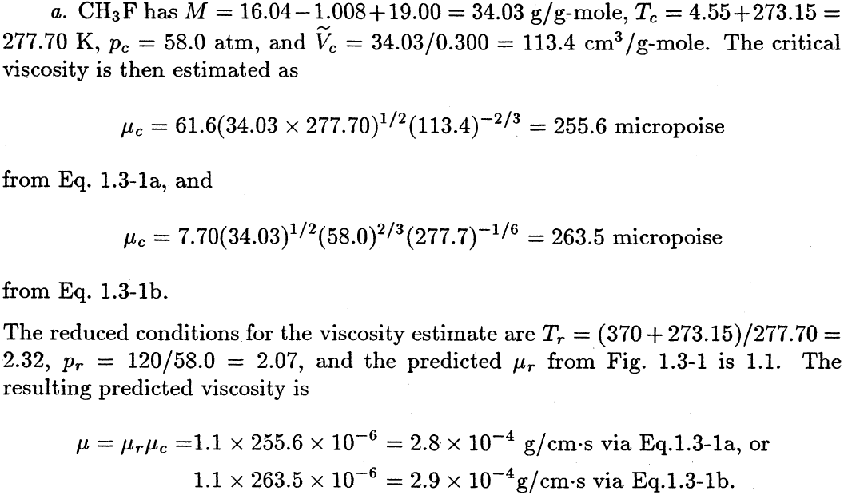

**1A.3 Computation of the viscosities of gases at low density.**

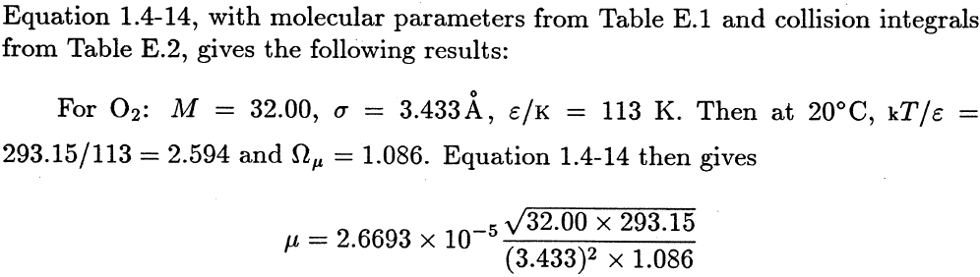

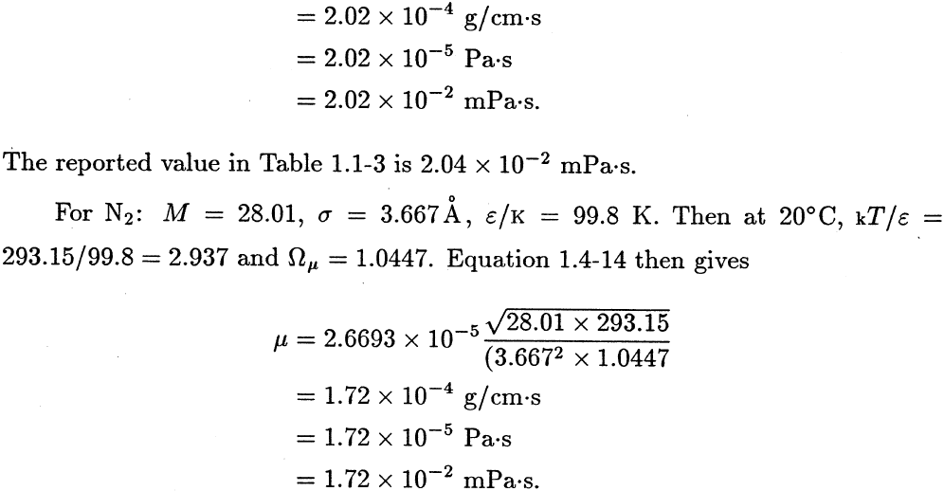

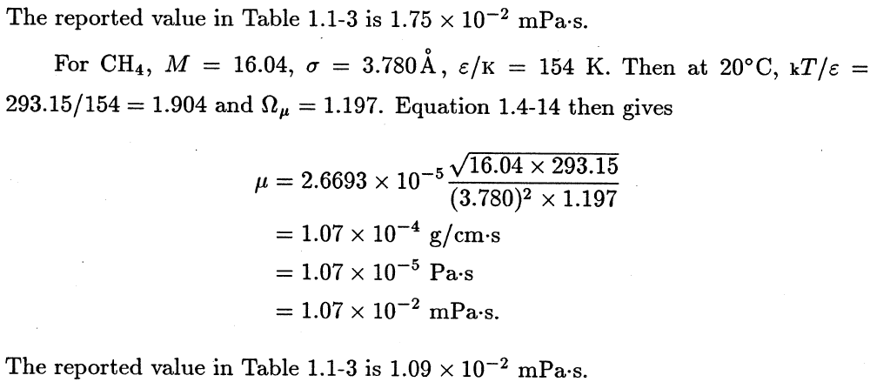

**1A.4 Gas-mixture viscosities at low density.**

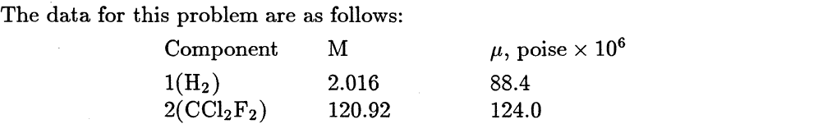

 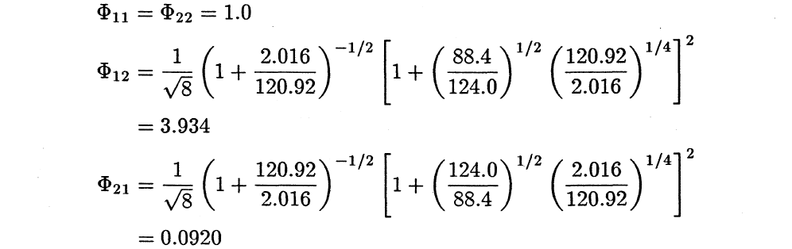

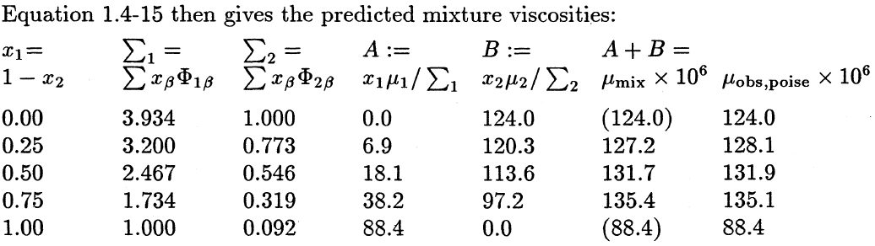

**1A.5 Viscosities of chlorine–air mixtures at low density.**

Predict the viscosities (in cp) of chlorine–air mixtures at 24°C and 1 atm, for the following mole fractions of chlorine: 0.00, 0.25, 0.50, 0.75, 1.00. Consider air as a single component and use Eqs. 1.4-14 to 16.

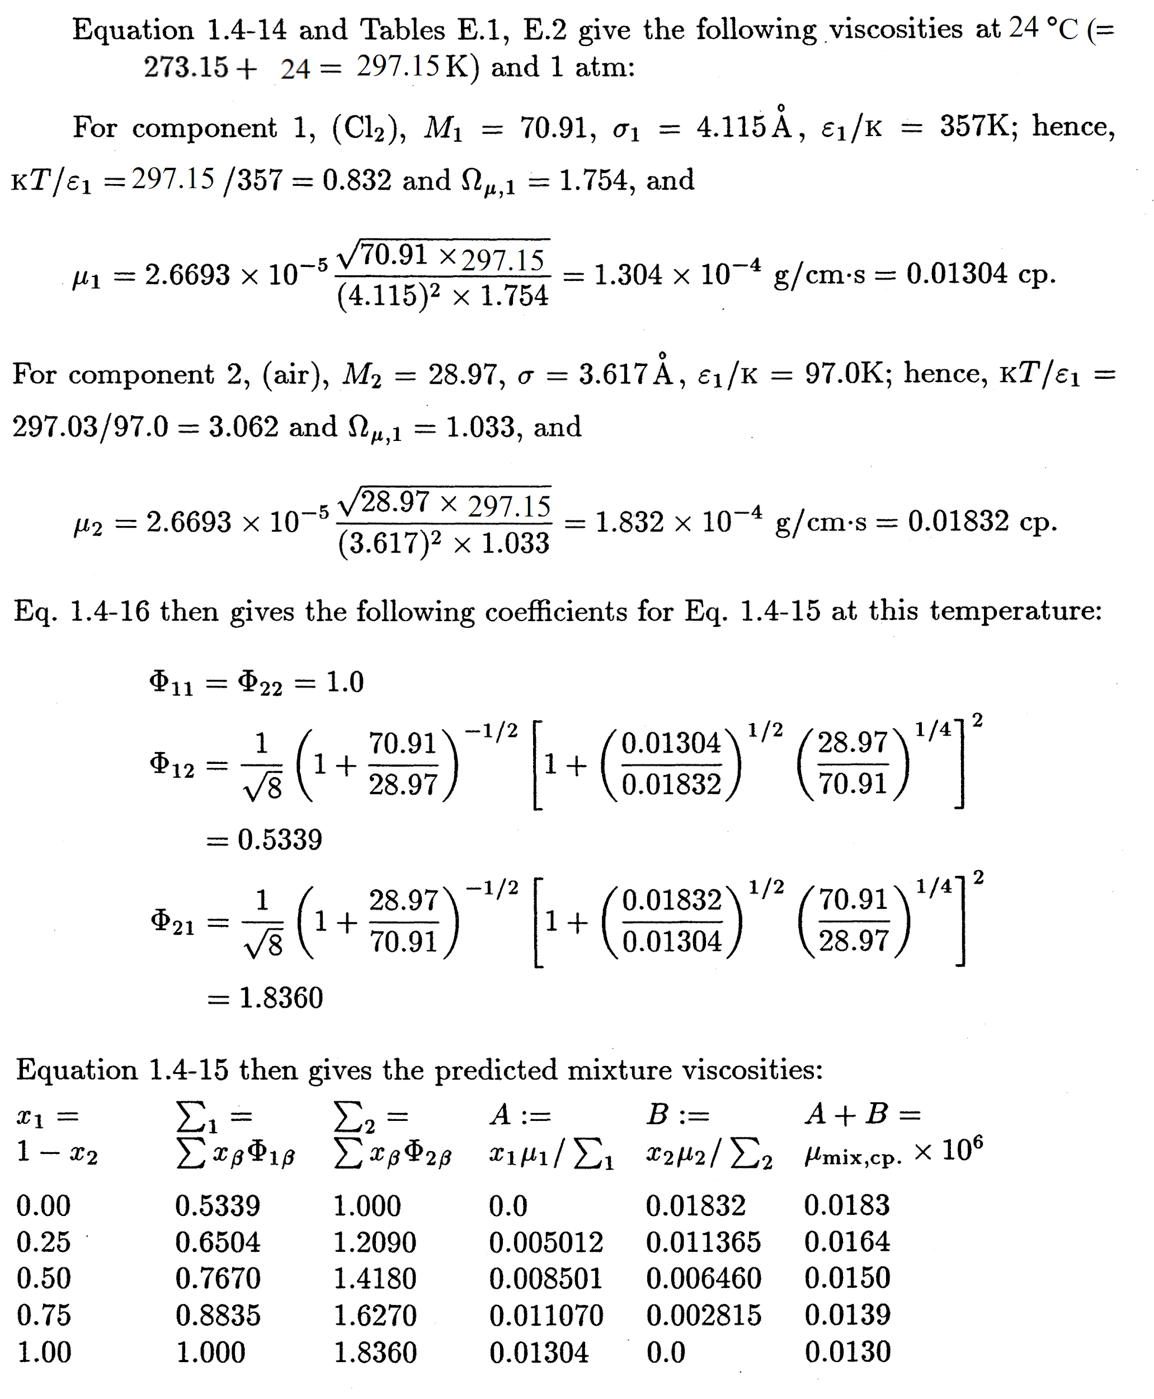

**1A.6 Estimation of liquid viscosity.**

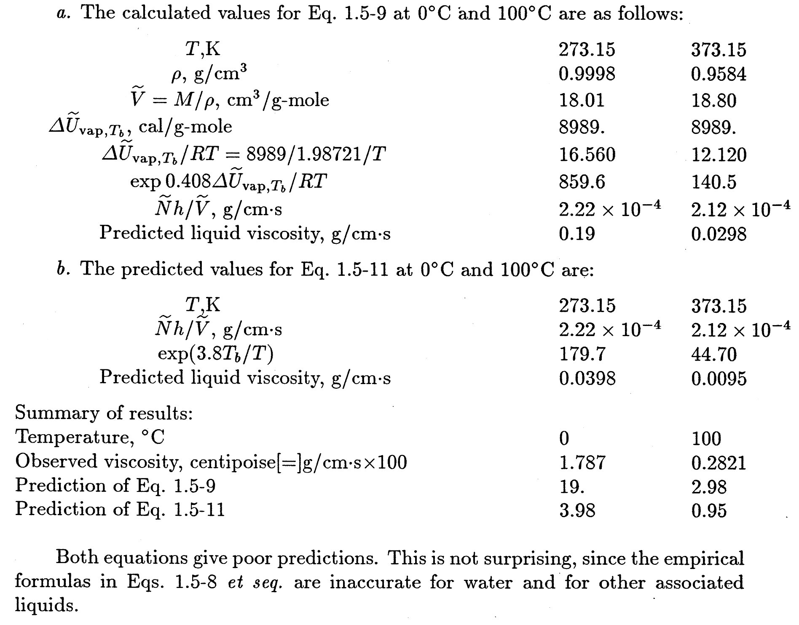

**1A.7 Estimation of Momentum flux:**

The velocity is linear so that

$$\frac{dv_{x}}{dy}=\frac{Δv_{x}}{Δy}=\frac{-0.1 m/s}{0.0002 m}= -500 s^{-1}$$

The viscosity of glycerol at 25°C from Table 1.1-3 is $934×10^{-3 }Pa.s$

Substitution into Eq. 1.1-2 gives

$$τ_{yx}= -μ \frac{dv_{x}}{dy}= -934×10^{-3} Pa.s ×500 s^{-1}=467 Pa$$

**1A.8 Estimation of liquid viscosity and Momentum flux:**

Use Eq. 1.5-11 with the following information

$$\hat{V}=59.68 cm^{3}/g-mole$$

$$T_{b}=78.37°C$$

Viscosity is given by:

$$μ=\frac{\underline{N}h}{V}exp(3.8T_{b}/T)$$

$$μ=\frac{(6.023×10^{23})(6.624×10^{-27})}{59.68}exp(\frac{3.8×(273.2+78.37)}{313.2})=4.76×10^{-3} g/cm.s$$

$$μ=4.76×10^{-4} Pa.s$$

The velocity is linear so that

$$\frac{dv_{x}}{dy}=\frac{Δv_{x}}{Δy}=\frac{-0.05 m/s}{5×10^{-3} m}= -10 s^{-1}$$

Substitution into Eq. 1.1-2 gives

$$τ_{yx}= -μ \frac{dv_{x}}{dy}= -4.76×10^{-4} Pa.s×10 s^{-1}=4.76×10^{-3} Pa$$

**1B.1 Velocity profiles and stress components**

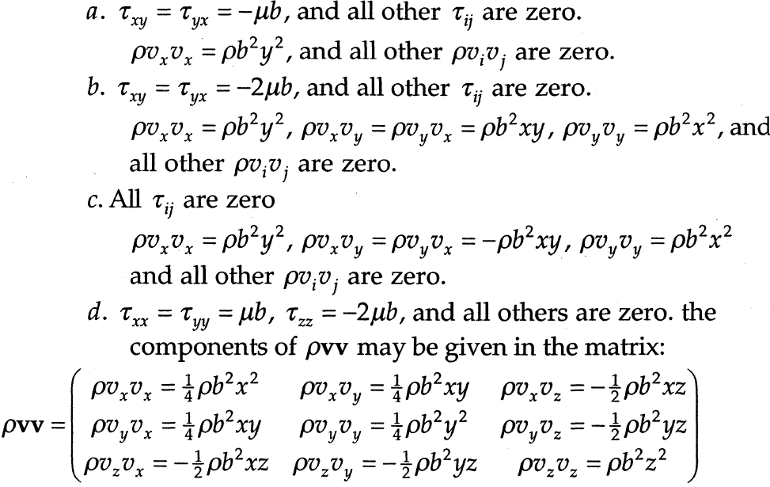

**1B.2 A fluid in a state of rigid rotation**

